10 DAYS – CAPTIVATING CENTRAL USA

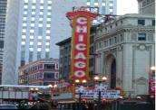
Day 01- Arrive in Chicago
Welcome to Chicago! Chicago is a city of world-class status and unsurpassed beauty. Located on the shores of Lake Michigan in the heart of the Midwest, Chicago is home to world-championship sports teams, an internationally acclaimed symphony orchestra, renowned architecture, award-winning theater, and much more.

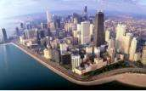
Day 02 –Chicago City Tour
Today you will go on a City Tour of Chicago, where you will see many sights! Some of the places you will see are Millennium Park, Theatre District, Navy Pier, John Hancock Observatory, Chicago Theatre, Macy’s on State Street, Water Tower& much more! After, you will also see the Willis Sears Tower, where you can look out over the city for a wonderful view! (Meals: B)

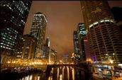
Day 03 - Chicago River & Architecture Tour
Today you will go on the Chicago River & Architecture tour, where you will take a cruise on the historic Chicago River where you will see over 40 landmarks of modern American Architecture. You will see buildings by world-famous architects including Mies van der Rohe, Skidmore Owings & Merrill, and Helmut Jahn. (Meals: B)

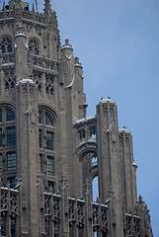
Day 04 - Chicago - Houston
Today, we proceed by plane/train/road to Houston. On arrival, transfer to your hotel. In the evening, we proceed for a city tour of Houston. This tour includes downtown, the Greater Houston Convention & Visitors Center, City Hall, Theater District, former banking district, Downtown stadiums, Discovery Green Park, Sam Houston Park, historic houses of worship, homes and cemeteries, famous buildings, Freedmen’s Town, River Oaks, the Rice Village, Rice University, and Hermann Park.(Meals: B)

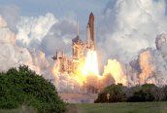
Day 05 - Space Center NASA Tour
Today, you will visit the Johnston Space Center in Houston. You will be guided through all the exhibits at the Houston Space Center. You will learn about the real space pioneers who made the dream a reality. Walk with people who have dedicated their life to exploring space. (Meals: B)



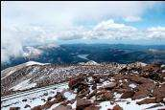

Day 06 - Houston - Denver
After breakfast, we proceed by plane/train/road to Denver. Today, you will proceed for a city tour and visit Brown Palace, Lower Downtown, Larimer Square, Coors Field, Mile High Stadium, Colorado State Capital, City Park, and the historic Neighborhood. (Meals: B)

Day 07 – Pikes Peak Region
Today, you will enjoy a day exploring Pikes Peak Region. This is the world’s most famous mountain, Pikes Peak. You will visit United States Air Force Academy, Cadet Chapel, Pikes Peak Highway, and Garden of the Gods. The breathtaking views will stay in your memories long after your vacation is over. (Meals: B)

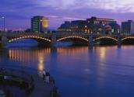
Day 08 - Denver - Rapid City
After breakfast, we proceed by plane/train/road to Rapid City. Rapid City offers a variety of shopping, dining, attractions and outdoor recreation. Stay in Rapid City and play in the Black Hills, where you can discover Mount Rushmore National Memorial, Custer State Park, Reptile Gardens, Storybook Island, Crazy Horse Memorial, Badlands National Park and much more. (Meals: B)

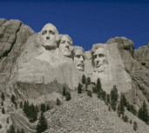
Day09- Grand Legends Mt. Rushmore
Today, you will take a tour of Mt. Rushmore. Welcome to western South Dakota, where sky-piercing granite peaks & forested mountains dominate. Tour the epic sculpture, Mt. Rushmore National Memorial, which stands as a shrine of democracy & symbolizes the greatness of this nation. Travel scenic Iron Mountain Road in Custer State Park. You will find wildlife, pigtail bridges, magnificent Black Hills scenery & tunnels that frame Mount Rushmore. Enjoy Crazy Horse Memorial, which honors the culture, tradition & living heritage of the North American Indians. (Meals: B)

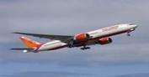
Day10- Departure from Rapid City
Today we finish our trip and get ready to fly back home or to the next
destination.(Meals: B)

PACKAGE COST & DETAILS
Category | 2 - 5 PAX (USD)
 | Double | Triple/CWB | Single | Child No Bed | Quad
Moderate | 2479 | 2379 | 3229 | 1739 | 2279
Deluxe | 2969 | 2869 | 4219 | 1759 | 2769

Inclusions:  - Hotel Accommodations  - Breakfast  - Airport- Hotel-Airport Transfers  - City Tour on SIC: Chicago, Houston, Denver  - Entrance Tickets with transfers: Architectural Cruise tour, Space NASA tour, Pikes Peak Region, Mt. Rushmore  - All tours & transfers on SIC  - All Taxes | Exclusions:  - International & Domestic Airfare  - Intercity travel by Flight / Bus / Train  - Meet & Greet at airport  - Any Destination Fees/Resort fees at any hotel  - Tips to guides & drivers  - Porterage, Laundry bills & other incidental charges  - For SIC tours – Hotel pick & drop not guaranteed. Client will have to arrange the transfer on its own for any SIC tours.  - Anything not mentioned in inclusions section
Optional cost per person:
- 2-5pax= Return PVT Airport trns Per Dest=
- USD 35.00 per person

HOTELS WILL BE AS BELOW OR SIMILAR:
City | Nts. | Moderate Hotels | Deluxe Hotels
CHI | 03 | Hotel Holiday Inn O'Hare / Wingate Inn O'Hare | Edward Hotel /Hyatt Place
HOU | 02 | Hotel Hampton Inn / Holiday Inn Express | Hotel Embassy Suites / Hilton
DEN | 02 | Hotel Ramada / Fairfield Inn | Hotel Sheraton / Doubletree Hilton / Marriott
Rapid | 02 | Hotel Laquinta Inn / Fairfield Marriott | Hotel Hilton Garden Inn / Radisson

BASIC INFORMATION:
Hotels | Transfer/Sightseeing’s | Meal
Check in: 4pm / Check out: 11am | 2-5 Pax – SIC basis | Breakfast: As provided by Hotel.
Breakfast time: 6:30 Am to 9:30 Am
Incidental Charges Must be paid by clients

TERMS & CONDITIONS:
- All rates are based on minimum 2Pax traveling together at all tours.
- Surcharges apply for any trade fair/special event/weekend in LAS or any other event in city.
- Child age à 2-9 years. Above 9 years is considered as an adult.
- All rates and availability are subject to change at the time of booking.
- Some events are seasonal like Maid of the Mist, Cave of the Winds, Beast ride, Yosemite Park, Lake Tahoe etc. (Will be closed for winter)
- Optional Meals do not include transfers; the meal will be delivered to your hotel if the restaurant is not within walking distance.
- SIC Tour / Transfer pick-up depends on hotel location, if hotel is outside of pick-up zone, clients will have to make own arrangements.
- We reserve the right to use alternative accommodation, sightseeing tours and transfer of equal or higher standard.
- No refunds either in part or full will be made for any unused services in above package like ground transportation, meals, accommodation, sightseeing tours.
- We are not responsible for any missed breakfast due to flight timings.
- No Intercity surface transfers are included unless specified in the package.
- We are not responsible for any baggage charges by any airlines for the clients.
- Payment for the tour must be made as per the invoice, payment terms & conditions.

