10 DAYS – EXOTIC EAST COAST USA

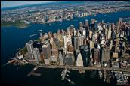
Day 01- Arrive in New York
Welcome to the "Big Apple," the "City That Never Sleeps"—New York is a city of superlatives: America's biggest; its most exciting; its business and cultural capitals; the nation's trendsetter. For more than a century, it has been one of the world's major centers of commerce and finance. Upon arrival at the airport, you will be transferred to the hotel.

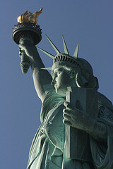
Day 02 - New York City Tour
After breakfast, we proceed for a City tour of New York. The sightseeing will include USA’s famous landmark, “Statue of Liberty.” We will take a ferry ride to Liberty Island for a spectacular view of the New York City Skyline. Next, we experience the view of a lifetime from the 86th floor of the Empire State Building. Later in the day, we drive through Rockefeller Center, Wall Street, Ground Zero and Central Park, Times Square, United Nations and Trump Tower. (Meals: B)

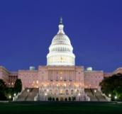
Day 03- New York – Washington D.C.
Today, we proceed by plane/train/road to Washington D.C., capital of the United States of America anda Guide to theHistoric Neighborhoods and Monuments. Other than the federal government, tourism is DC's biggest industry. The city attracts almost twenty million visitors each year. After checking in at the hotel, you will explore the capital city of US. Seethe White House, Lincoln Memorial, Supreme Court, the Capitol Building, the Smithsonian Air and Space Museum, Union Station, World War II Memorial Building, Pentagon building and Washington monument. (Meals: B)

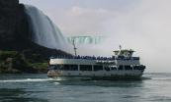
Day 04- Washington - Buffalo - USA side Niagara Falls
Today, we proceed by plane/train/road to view the world-famous falls, which form one of the natural Wonders of the World. (Meals: B)

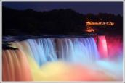
Day 05- USA side Niagara Falls
We will board the famous boat, “Maid of the Mist,” which takes us close to the thundering falls and around the American and Horseshoe Falls (seasonal). Return to the hotel to freshen up after your damp ride. (Meals: B)



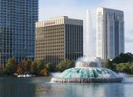
Day 06- Buffalo - Orlando
Today, we proceed by plane/train/road to Orlando by flight. Orlando is the sixth largest city of Florida and is also known to be its largest inland city. The presence of the Disney World theme park has made this city a well-known vacation spot. This city is said to welcome more than 52 million tourists every year. Upon arrival transfer to your hotel (Meals: B)

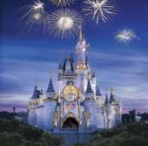
Day 07- Orlando- Walt Disney Magic Kingdom

Today, you will visit The Magic Kingdom, which covers 107 acres and was opened on October 1, 1971. It's been dubbed "The Most Magical Place on Earth!" and is home to seven themed lands, and dozens of attractions that appeal to all ages. It is the place where storybook fantasy is everyday reality, and Disney classics are brought to life. From the moment you step onto Main Street USA, you are transported to a place where the cares of the outside world seem to magically melt away. (Meals: B)

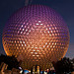
Day 08- Orlando – Epcot Center
Begin your day at the Epcot center, where you can touch the future and travel the world with an amazing array of attractions and live performances. This is an area of 260 acres devoted to past achievements and the future of technology. World showcase offers a kind of permanent World Fair, with pavilions devoted to eleven countries. (Meals: B)

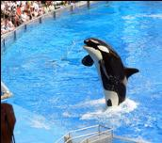
Day 09- Orlando Sea World
Today, you will visit the world's largest Marine Park, Sea World. Here, you shall discover many attractions. We dare you to take a one-of-a kind water coaster thrill ride through the mysterious lost city of Atlantis. Soar through danger on a jet copter ride to the Wild Arctic. At Sea World, touch, feed or get face to face with awesome and amazing wild animals, and get in on all the action that draws you back again and again! (Meals: B)

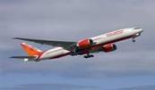

Day 10- Departure from Orlando

After breakfast, we will depart for the airport to board your flight for next destination. (Meals: B)

PACKAGE COST & DETAILS
Category | 2 - 5 PAX (USD)
 | Double | Triple/CWB | Single | Child No Bed | Quad
Moderate | 2419 | 2319 | 3209 | 1629 | 2219
Deluxe | 2749 | 2649 | 3799 | 1729 | 2549

Inclusions:  - Hotel Accommodations  - Breakfast  - Airport- Hotel-Airport Transfers  - City Tour on SIC: New York, Washington D.C.  - Entrance Tickets with transfers: Statue of Liberty, Empire State Building, Sea World, Epcot Center, Magic Kingdom.  - Entrance Tickets without transfers: Maid of the Mist (walking distance from Hotel)  - All tours & transfers on SIC  - All Taxes | Exclusions:  - International & Domestic Airfare  - Intercity travel by Flight / Bus / Train  - Supplement cost applicable for Weekend in NIA  - Any Destination Fees/Resort fees at any hotel  - Meet & greet at airport  - Tips to guides & drivers  - Porterage, Laundry bills & other incidental charges  - For SIC tours – Hotel pick & drop not guaranteed. Client will have to arrange the transfer on its own for any SIC tours.  - Anything not mentioned in inclusions section
Optional cost per person:
- 2-5pax= Return PVT Apt trns Per Dest=
USD 35.00 per person

HOTELS WILL BE AS BELOW OR SIMILAR:
City | Nts. | Moderate Hotels | Deluxe Hotels
NYC | 02 | Hotel Fairfield Inn Manhattan / Holiday Inn Manhattan | Hotel Doubletree Manhattan / Hyatt Place
WAS | 01 | Hotel Comfort Inn / Best Western | Hotel Doubletree Dulles / Wyndham Garden
NIA | 02 | Hotel Quality Inn at Falls / Laquinta | Hotel Hyatt Place / Holiday Inn at Falls
ORL | 04 | Hotel Comfort Inn / Fairfield Inn | Hotel Four Point Sheraton / Courtyard Marriott

BASIC INFORMATION:
Hotels | Transfer/Sightseeing’s | Meal
Check in time: 4pm / Check out time: 11am | 2-5 Pax – SIC basis | Breakfast: As provided by hotel.
Breakfast time: 6:30 Am to 9:30 Am
Incidental Charges Must be paid by clients

TERMS & CONDITIONS:
- All rates are based on minimum 2Pax traveling together at all tours.
- Surcharges apply for any trade fair/special event/weekend in LAS or any other event in city.
- Child age à 2-9 years. Above 9 years is considered as an adult.
- All rates and availability are subject to change at the time of booking.
- Some events are seasonal like Maid of the Mist, Cave of the Winds, Beast ride, Yosemite Park, Lake Tahoe etc. (Will be closed for winter)
- Optional Meals do not include transfers; the meal will be delivered to your hotel if the restaurant is not within walking distance.
- SIC Tour / Transfer pick-up depends on hotel location, if hotel is outside of pick-up zone, clients will have to make own arrangements.
- We reserve the right to use alternative accommodation, sightseeing tours and transfer of equal or higher standard.
- No refunds either in part or full will be made for any unused services in above package like ground transportation, meals, accommodation, sightseeing tours.
- We are not responsible for any missed breakfast due to flight timings.
- No Intercity surface transfers are included unless specified in the package.
- We are not responsible for any baggage charges by any airlines for the clients.
- Payment for the tour must be made as per the invoice, payment terms & conditions.

