10 DAYS - FASCINATING FLORIDA

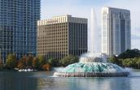
Day 01-Orlando

Welcome to Orlando. Orlando is the sixth largest city of Florida and is also known to be its largest inland city. The presence of the Disney World theme park has made this city a well-known vacation spot. The city is said to welcome more than 52 million tourists every year. Upon arrival, transfer to your hotel.

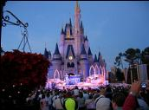
Day 02 - Orlando- Walt Disney Magic Kingdom
Today you visit Magic Kingdom, which covers 107 acres and was opened on October 1, 1971. It's been dubbed "The Most Magical Place on Earth!" and is home to seven themed lands, and dozens of attractions that appeal to all ages. It is the place where storybook fantasy is everyday reality, and Disney classics are brought to life. From the moment you step onto Main Street USA, you are transported to a place where the cares of the outside world seem to magically melt away.
(Meals: B)

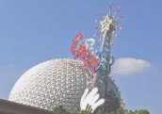
Day 03 - Orlando- Epcot Center
Begin your day at the Epcot center, where you can touch the future and travel the world with an amazing array of attractions and live performances. This is an area of 260 acres devoted to past achievements and the future of technology. World showcase offers a kind of permanent World Fair, with pavilions devoted to eleven countries. (Meals: B)

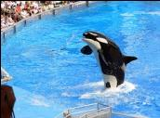
Day 04 - Orlando – Sea World
Today you will visit the world's largest Marine Park, Sea World. Here, you shall discover many attractions. We dare you to take a one-of-a kind water coaster thrill ride through the mysterious lost city of Atlantis. Soar through danger on a jet copter ride to the Wild Arctic. At Sea World, touch, feed or get face to face with awesome and amazing wild animals, and get in on all the action that draws you back again and again! (Meals: B)

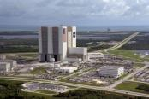
Day 05- Orlando- Kennedy Space Center
Today you will explore Kennedy Space Complex. You will go on the Discover KSC: Today & Tomorrow Tour. Here you will see the closest viewing location of the paces shuttle launch pads, the Shuttle Landing Facility, a panoramic view of all launch pads from the NASA Causeway & catch a glimpse of NASA's gigantic Crawler Transporters. (Meals: B)

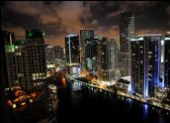
Day 06 - Orlando-Miami
Today, you will proceed on your own by plane/train/road to Miami, Florida. Miami is one of the state’s most popular vacation spots. It is well known for its beaches including South Beach, trendy nightlife, the Art Deco district, Calle Ocho & Little Havana. You will check into your hotel & have the rest of the afternoon at your leisure. Enjoy the beach or just relax before enjoying a wonderful meal at restaurant. (Meals: B)

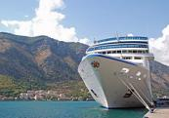
Day 07-Miami City tour with Biscayne Bay Cruise

Today, you will go on a City Tour of Miami, where you will see many sights. You will see Central Station/Bayfront Park, Ocean Drive, Lincoln Road, Collins Avenue & 24th, Design District, Midtown Miami, Coconut Grove, Little Havana and much more. You will also enjoy going on the Biscayne Bay by Boat Tour, you will cruise along Miami's Biscayne Bay. (Meals: B)

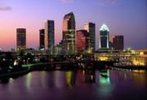
Day 08- Miami - Tampa
Today, you will transfer on your own to Tampa. Tampa is known for its theme
parks, amazing beaches, premier Sports facilities, art & culture, night life &
golf courses. Glistening waterways wrap around the region's miles of coastline,
providing scenic lookouts and passage ways for dolphins, manatees and other
aquatic creatures. (Meals: B)

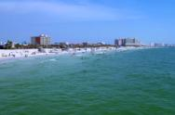

Day 09- Tampa Busch Garden

Today, you will visit the most famous Busch Gardens in Tampa. Busch Gardens in Tampa is the ultimate family adventure park, featuring an unparalleled combination of animal encounters, live entertainment and world-class thrill rides. (Meals: B)

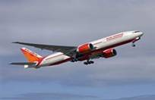

Day 10 -Fly Out

After breakfast, you will head to the airport to board your flight for the next destination. (Meals: B)

PACKAGE COST & DETAILS
Category | 2 - 5 PAX (USD)
 | Double | Triple/CWB | Single | Child No Bed | Quad
Moderate | 2589 | 2489 | 3279 | 1889 | 2389
Deluxe | 3029 | 2919 | 4119 | 1929 | 2819

Inclusions:  - Hotel Accommodations  - Breakfast  - Airport- Hotel-Airport Transfers  - City Tour on SIC: Miami, Tampa  - Entrance Tickets with transfers: Sea World, Epcot Center, Magic Kingdom, Kennedy Space Center, Biscayne Miami Cruise, Busch Garden  - All tours & transfers on SIC  - All Taxes | Exclusions:  - International & Domestic Airfare  - Intercity travel by Flight / Bus / Train  - Any Destination Fees/Resort fees at any hotel  - Meet & greet at airport  - Tips to guides & drivers  - Porterage, Laundry bills & other incidental charges  - For SIC tours – Hotel pick & drop not guaranteed. Client will have to arrange the transfer on its own for any SIC tours.  - Anything not mentioned in inclusions section
Optional cost per person:
- Surface transfer ORL-MIA(SIC)= USD 89.00 per person
- 2-5pax= Return PVT Airport trns Per Dest=
USD 35.00 per person

HOTELS WILL BE AS BELOW OR SIMILAR:
City | Nts. | Moderate Hotels | Deluxe Hotels
ORL | 05 | Hotel Fairfield Inn / Comfort Inn | Hotel Four Point Sheraton / Courtyard Marriott
MIA | 02 | Hotel Ramada Marco Polo / Holiday Inn | Hotel Springhill Suites Marriott / Embassy Suites
TPA | 02 | Hotel Hampton Inn / Ramada | Hotel Doubletree / Hyatt Place

BASIC INFORMATION:
Hotels | Transfer/Sightseeing’s | Meal
Check in: 4pm / Check out: 11am | 2-5 Pax – SIC basis | Breakfast: As provided by Hotel.
Breakfast time: 6:30 Am to 9:30 Am
Incidental Charges Must be paid by clients

TERMS & CONDITIONS:
- All rates are based on minimum 2Pax traveling together at all tours.
- Surcharges apply for any trade fair/special event/weekend in LAS or any other event in city.
- Child age à 2-9 years. Above 9 years is considered as an adult.
- All rates and availability are subject to change at the time of booking.
- Some events are seasonal like Maid of the Mist, Cave of the Winds, Beast ride, Yosemite Park, Lake Tahoe etc. (Will be closed for winter)
- Optional Meals do not include transfers; the meal will be delivered to your hotel if the restaurant is not within walking distance.
- SIC Tour / Transfer pick-up depends on hotel location, if hotel is outside of pick-up zone, clients will have to make own arrangements.
- We reserve the right to use alternative accommodation, sightseeing tours and transfer of equal or higher standard.
- No refunds either in part or full will be made for any unused services in above package like ground transportation, meals, accommodation, sightseeing tours.
- We are not responsible for any missed breakfast due to flight timings.
- No Intercity surface transfers are included unless specified in the package.
- We are not responsible for any baggage charges by any airlines for the clients.
- Payment for the tour must be made as per the invoice, payment terms & conditions.

