12 DAYS – ALOHA HAWAII

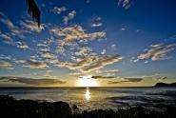
Day 01 - Welcome to Hawaii
Welcome to Oahu Island! Oahu is a mix of natural, historical and cultural experiences. You’ll enjoy Waikiki beach and the picturesque Pali lookout to name a few points of interest. Wherever you go, whatever you do on Oahu, you’ll have plenty of opportunities to enjoy this island’s treasures all the while being showered with the Aloha Spirit of Hawaii.

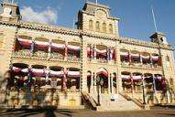
Day 02 - Pearl Harbor& Historical Honolulu City Tour

Today you will take a tour to visit the Arizona Memorial & Pearl Harbor, where we will transport you to the morning of December 7, 1941 as you re-live the moment that thrust America into World War II. Your journey continues with a visit to Punchbowl National Cemetery of the Pacific & Courts of the Missing. Then you will see Honolulu's historic district which drive by `Iolani Palace, the only royal palace on American soil, Kawaiahao Church, the State Library and Archives and much more. (Meals: B)

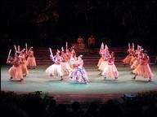
Day 03 - Deluxe Circle Island Tour

Today you will go on the Circle Island Tour, which lets you explore the historical, scenic, & cultural highlights of Oahu. The tour includes Diamond Head, Hanauma Bay, Dole Plantation, famous North Shore beaches, the Hawai'i Temple& more. (Meals: B)

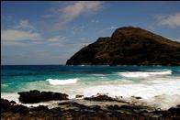
Day 04 - Diamond Head Scenic Coast Tour


Today you will head east towards Makapuu Point, Oahu's southeastern tip & an amazing lookout point. Then you're off to the nearby Halona Blowhole, an underwater lava tube that shoots water high into the air when waves flow into it. From here you also have a great view of Sandy Beach. Your tour guide will show you Kahala, the Beverly Hills of Oahu. It's where Hawaii's millionaires have their multi-million dollar mansions, surrounded by meticulously manicured, tropical gardens. (Meals: B)

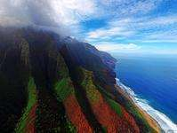
Day 05 - Honolulu-Kauai
Today you will get on a plane to transfer to Kauai. Welcome to Kauai – From the soaring cliffs of the Napali Coast to the vast chasms of the Waimea Canyon, Kauai embraces the senses like no other destination. Discover 50-miles of heavenly beaches & the charming historic small towns with no building taller than a coconut tree. You will check into your hotel and have the rest of the day at your leisure. (Meals: B)

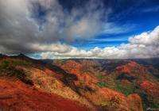
Day 06 - Kauai- Waimea Canyon Tour

Today you will go on a Kauai Waimea Canyon Experience & Wailua River Tour. Today you will enjoy a day filled with the lush beauty, legends and saga of Hawaii’s “Garden Isle.” Waimea Canyon is over 10 miles long & almost 4,000 feet deep this was formed by erosion & the catastrophic collapse of the volcano that created Kauai. Then go for a river boat cruise on Wailua River, sail up this historic & sacred river. (Meals: B)

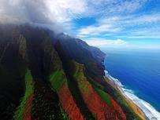
Day 07 -Kauai- Maui

Today you will board a plane to Maui. Welcome to Maui – Discover your own reason to love Maui. From the seaside streets of Lahaina, the lovely beaches of Kaanapali, over 120-miles of beaches, the arts & culture of Kahului and one of the best places to whale watch in the world. The Road to Hana has 600 curves & 54 bridges & is one of the world’s most scenic drives. You will check into your hotel & have the rest of the day at your leisure. (Meals: B)

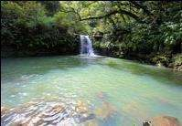
Day 08 - Maui- Hana Bus Tour

Today you will go on the Hana Bus Tour. Feast your eyes on bamboo jungles, breezy Eucalyptus groves & roadside fruit stands. You will see Paia Town, which is the “surf capital of the world.” Onward to Kaumahina State Park, where there are several trails uphill from the ocean to Keanae Lookout. You will also see the black sand on an ancient lava flow includes sea cliffs, lava tubes, arches & the beach in Waianapanap State Park & Beach. (Meals: B)

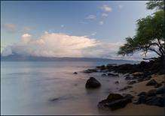
Day 09 - Maui- City Tour

Today you will go on a Historical Valley & City Tour; you will see Maui’s most popular sights. Iao Valley is a tranquil, lush paradise of exotic plants & natural pools. From there, you’ll head to the little historic fishing village of Lahaina, now a mecca for shoppers & anyone seeking fun. Check out the 110-year-old Banyan tree, the Pioneer Inn Hotel built in 1906 & the wharf’s bits of history that have been carefully preserved. Since the 1700s, when King Kamehameha made it his home, Lahaina has been a casual place of merriment. (Meals: B)

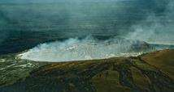
Day 10 - Maui- Big Island

Today you will fly to Big Island; the biggest & exotic island of Hawaii. Upon arrival enjoy the rest of the day at leisure exploring the city. (Meals: B)

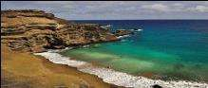
Day 11 - Grand Island Circle Bus Tour

After breakfast, we will explore the Hawaii Grand Circle Island by bus. Enjoy the scenic 260 mile Hawaii Circle Island tour, Coffee Plantation, Hawaii Volcanoes National Park, Fern Tree Jungle, Hilo City, Waimea and much more. (Meals: B)

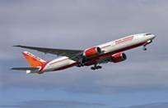
Day 12 - Departure
After breakfast, spend some time at leisure. Depart for the airport to board your flight for next destination. (Meals: B)

PACKAGE COST & DETAILS
Category | 2 - 5 PAX (USD)
 | Double | Triple/CWB | Single | Child No bed | Quad
Moderate | 4289 | 4169 | 5809 | 2809 | 4049
Deluxe | 5829 | 5709 | 8859 | 2859 | 5589

Inclusions:  - Hotel Accommodations  - Breakfast  - Airport- Hotel-Airport Transfers  - Pearl Harbor & Honolulu City tour  - Deluxe Circle Island tour  - Diamond Head Scenic Coast tour  - Waimea Canyon Bus tour  - Hana Bus tour  - Maui City tour  - Grand Island Circle Bus tour- Big Island  - All tours & transfers on SIC  - All Taxes | Exclusions:  - International & Domestic Airfare  - Intercity travel by Flight / Bus / Train  - Meet & Greet at airport  - Any Destination Fees/Resort fees at any hotel  - Tips to guides & drivers  - Porterage, Laundry bills & other incidental charges  - For SIC tours – Hotel pick & drop not guaranteed. Client will have to arrange the transfer on its own for any SIC tours.  - Anything not mentioned in inclusions section
Optional cost per person:
- 2-5pax= Return PVT Airport trns Per Dest=
USD 35.00 per person

HOTELS WILL BE AS BELOW OR SIMILAR:
City | Nts. | Moderate Hotels | Deluxe Hotels
HNL | 04 | Hotel Ramada Plaza / Astor Waikiki | Hotel Hyatt Place / Sheraton
Kauai | 02 | Hotel Aston Islander / Outrigger | Hotel Marriott / Westin
Maui | 03 | Hotel Aston / Hotel Wailea | Hotel Westin / Sheraton / Marriott
Big Is | 02 | Hotel Royal Kona / Castle Hilo | Hotel Hilton / Sheraton

TERMS & CONDITIONS:
- All rates are based on minimum 2Pax traveling together at all tours.
- Surcharges apply for any trade fair/special event/weekend in LAS or any other event in city.
- Child age à 2-9 years. Above 9 years is considered as an adult.
- All rates and availability are subject to change at the time of booking.
- Some events are seasonal like Maid of the Mist, Cave of the Winds, Beast ride, Yosemite Park, Lake Tahoe etc. (Will be closed for winter)
- Optional Meals do not include transfers; the meal will be delivered to your hotel if the restaurant is not within walking distance.
- SIC Tour / Transfer pick-up depends on hotel location, if hotel is outside of pick-up zone, clients will have to make own arrangements.
- We reserve the right to use alternative accommodation, sightseeing tours and transfer of equal or higher standard.
- No refunds either in part or full will be made for any unused services in above package like ground transportation, meals, accommodation, sightseeing tours.
- We are not responsible for any missed breakfast due to flight timings.
- No Intercity surface transfers are included unless specified in the package.
- We are not responsible for any baggage charges by any airlines for the clients.
- Payment for the tour must be made as per the invoice, payment terms & conditions.

