12 DAYS- AMAZING SOUTH AMERICA

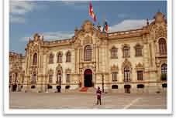
Day 01 - Lima
Arrive in Lima, the capital of Peru, and proceed for the city tour to visit the Main Square (Plaza Mayor), Government Palace, City Hall, the Catherdral, the San Francisco Convent and its "Catacombs," ancient underground cemetery of Lima, El Oidor, Torre Tagle Palace, a beautiful mansion, and the Osambela House. Afterwards, visit the Gold Museum and splendid collection of guns. The tour continues to the modern and high end side of Lima city, the Mira Flores. Overnight in Lima.

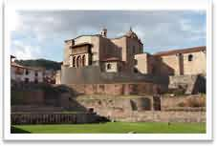
Day 02-Lima - Cuzco
Today, we proceed by plane/train/road to Cuzco. Arrive at the hotel, and after acclimating to the altitude, proceed to city tour in the afternoon. Visit nearby Ruins "Cusco” of Tambo achy, Kenki, Puca - Pucara, and finally the fortress of Sacsayhuaman. Also visit the Koricanchaor temple of the Sun. Overnight in Cuzco. (Meals: B)

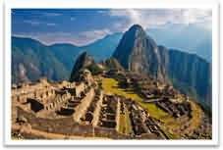
Day 03- Machu Picchu - Cuzco
After breakfast, begin your day with a breathtaking train ride, which goes through Urubamba Valley and mountain top ruins of Machu Picchu. Machu Picchu is eye tantalizing tribute to man in harmony with nature. It is located high above the clouds. Machu Picchu has become one of most popular destinations in South America, high above the Sacred Valley. Take afternoon train back to Cusco and overnight in the hotel. (Meals: B)

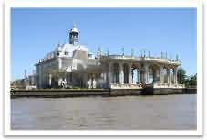
Day 04 - Cuzco - Buenos Aires
Today, we proceed by plane/train/road to Buenos Aires, the capital of Argentina. After completing all the immigration formalities, you will be transferred to the hotel. Buenos Aires is, with over 11 million inhabitants, one of the largest cities in Argentina. A city with modern structure and dynamic activities has found the way to preserve old traditions &lovely spots. Overnight in Buenos Aires.(Meals: B)

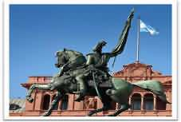

Day 05 - Buenos Aires
After breakfast, we start the city tour of Buenos Aires. Visit "Plaza de Mayo," the Pink House, the Buenos Aires Cathedral, the 9 of July Avenue, the Colon Theatre, La Boca neighborhood with the traditional "Caminito Street," "San Martin Plaza,"Recoleta Cemetery, and the Palermo Woods. In the afternoon, we will tour the Tigre and Parana’s Delta River. Then we will return by bus along the Panamerican Highway to the city of Buenos Aires. Overnight in Buenos Aires.(Meals: B)

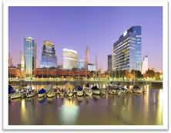
Day 06 - Buenos Aires
After breakfast, enjoy a full day Fiesta Gaucho Tour at Estancia Santa Susana and meet 'gauchos' in their own environment. Ride to the outskirts of the city into the countryside, the 'pampas', cradle of the 'gaucho' and the rich 'gaucho' tradition. Visit typical Estancia in Buenos Aires Province who welcomes you with delicious Argentine 'empanadas'. After dinner, proceed to enjoy the LA VENTANA, TANGO SHOW. This is a diverse and superb Tango show with the great tango orchestras of the forties. Also included are a folklore show with dancers and musicians from the Altiplano. Overnight in Buenos Aires.(Meals: B)

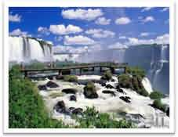
Day 07 - Buenos Aires - Iguassu Falls
Today, we proceed by plane/train to Iguassu Falls, located on the border of Brazil, Argentina, and Paraguay. After checking in to the hotel, we proceed to enjoy the Iguassu Falls National Park, touring the Brazilian side of the fall. You will walk with the guide, descending a walkway, contemplating the lovely waterfalls in all of nature's exuberance, with panoramic views of both sides - Brazilian and Argentinean. Reach the highest elevation, then descend into the Brazilian side lookout, this provides magnificent photo opportunities and views. Overnight in Iguassu.(Meals: B)

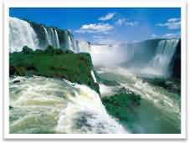
Day 8 - Iguassu Falls
After breakfast, visit the Argentina side of the falls, taking a guided walking tour of this natural wonderland. You will see a never to be forgotten spectacle of 275 cataracts from different angles, walking through the raised platforms, getting near the Devil’s Throat and its immense amount of water spilled, causing wetness to a large area around it. After lunch, we tour the Itaipu Dam, which is one of the world's largest hydroelectric power plants and a technological wonder. Stop at panoramic overlooks for photo opportunity. The spectacle of the spillway of the dam, with its huge flow of water is particularly impressive.Overnight in Iguassu.(Meals: B)

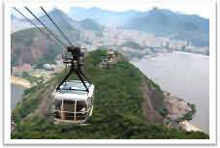
Day 9-Iguassu Falls -Rio de Janeiro
Today, we proceed by plane/train to Rio de Janeiro. Upon arrival, transfer to the hotel, check-in, and enjoy lunch. Afternoon is at leisure, so you can relax at the hotel. We will visit the Sugar Loaf drive to "Praia Vermelha" (Red beach), to take the two stage car up to the top of Sugar Loaf, which grants the entrance to Rio's harbor and Guanabara Bay. The cable car holds 80 passengers and each of the two stages takes two minutes. The first stage is Morro da Urca & the second stage goes to the Sugar Loaf itself, the view is spectacular at sunset. Overnight in Rio. (Meals: B)

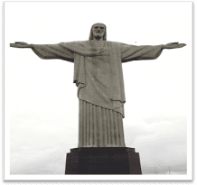
Day10 - Rio de Janeiro City Tour
After breakfast, enjoy a full day city tour of Rio. Ascend on Corcovado Mountain by train to visit one of the world’s most famous landmarks, the gigantic statue of Christ, the Redeemer. Then proceed to Cascatinha, Tijuca Forest, to the top of Corcovado Mountain. Cidade Maravilhosa, "the marvelous city" as it is known to its residents and the rest of Brazil, is also the most beautiful city in the world. As a tropical resort, Rio offers miles of golden beaches, including, Ipanema and Copacabana, two of the most famous stretches of sand in the world. The tour continues with the visit to Metropolitan Cathedral, samba stadium and view of architectonic monuments of Rio. Overnight in Rio. (Meals: B)

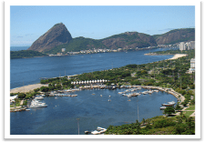
Day 11 - Rio de Janeiro
After breakfast, we will take a boat tour of Guanabara Bay, viewing the incredible “Wonder City” from its most famous bay, and has several islands such as the Governor's Island and Snakes Island. To the west lies Rio de Janeiro, and facing east, the municipal district of Niteroi. Various sights and landmarks such as the neighborhoods of Botafogo, Flamengo, Urca, Sugar Loaf Mountain, Fort Sao Joao, Flagstone Island, Santa Cruz Fortress, Rio-Niteroi Bridge and more will be seen as we depart from the Marina da Gloria. Overnight in Rio.(Meals: B)

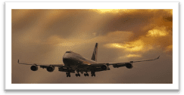

Day12-Rio de Janeiro
Today we will check out from the hotel, transfer to airport and board the flight. Your memorable trip to South America ends here as you return back home. (Meals: B)

PACKAGE COST & DETAILS

Category | 2 - 5 PAX (USD)
 | DBL | TRL/CWB | SGL | CNB | Quad
Deluxe | 4729 | 4609 | 5829 | 3629 | 4489

Inclusions:  - Deluxe Hotel Accommodations  - Breakfast  - Airport- Hotel-Airport Transfers  - City Tour on SIC: Lima, Cuzco, Rio, Buenos, Iguassu  - Entrance Tickets with transfers: Machu Picchu, Tiger Hill, Tango Show, Corcovado, Sugar Loaf, Iguassu Falls Boat ride, Fiesta Gaucha Tour, Guanabara Bay Boat tour  - All tours & transfers on SIC  - AllTaxes | Exclusions:  - International & Domestic Airfare  - Intercity travel by Flight / Bus / Train  - Meet & Greet at airport  - Any Destination Fees/Resort fees at any hotel  - Tips to guides & drivers  - Porterage, Laundry bills & other incidental charges  - For SIC tours – Hotel pick & drop not guaranteed. Client will have to arrange the transfer on its own for any SIC tours.  - Anything not mentioned in inclusions section

HOTELS WILL BE AS BELOW OR SIMILAR
City | Nts. | Deluxe Hotels
Lima | 01 | Hotel Casa Andina / Novotel or similar
Cuzco | 02 | Hotel Sonesta / Ramada or similar
Buenos Aires | 03 | Hotel Bel Air / Nogarao or similar
Iguassu Falls | 02 | Hotel Recanto or similar
Rio | 03 | Hotel Ocean Copabana / Copu Sul or similar

BASIC INFORMATION:
Hotels | Transfer | Meal
Check in time: 4pm / Check out time: 11am | 2-5Pax – SIC basis | Breakfast: As provided by Hotel.
Breakfast time: 6:30 Am to 9:30 Am
Incidental Charges Must be paid by clients

TERMS & CONDITIONS:
- All rates are based on minimum 2Pax traveling together at all tours.
- Surcharges apply for any trade fair/special event/weekend in LAS or any other event in city.
- Child age à 2-9 years. Above 9 years is considered as an adult.
- All rates and availability are subject to change at the time of booking.
- Some events are seasonal like Maid of the Mist, Cave of the Winds, Beast ride, Yosemite Park, Lake Tahoe etc. (Will be closed for winter)
- Optional Meals do not include transfers; the meal will be delivered to your hotel if the restaurant is not within walking distance.
- SIC Tour / Transfer pick-up depends on hotel location, if hotel is outside of pick-up zone, clients will have to make own arrangements.
- We reserve the right to use alternative accommodation, sightseeing tours and transfer of equal or higher standard.
- No refunds either in part or full will be made for any unused services in above package like ground transportation, meals, accommodation, sightseeing tours.
- We are not responsible for any missed breakfast due to flight timings.
- No Intercity surface transfers are included unless specified in the package.
- We are not responsible for any baggage charges by any airlines for the clients.
- Payment for the tour must be made as per the invoice, payment terms & conditions.

