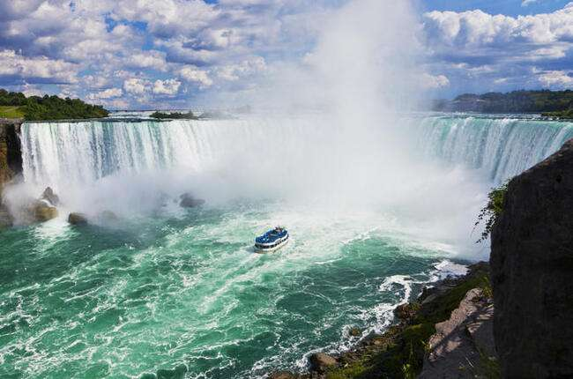
13 DAYS – BEST OF CANADA

Day 01 –Arrive in Toronto
Welcome to Toronto! A fabulous waterfront city lying on the north shore of Lake Ontario, Toronto is Canada’s largest and most cosmopolitan city. Upon Arrival, Check in Hotel. Later proceed for dinner. (Meals: D)

Day 02 – Toronto City tour + CN tower
After breakfast, we proceed for a City Tour of Toronto, where you will explore the Hockey Hall of Fame, CN Tower, Rogers Centre, Air Canada Centre, Olympic Spirit, Toronto's Harbor front, St. Lawrence Market, the Entertainment District, Casa Loma, the Royal Ontario Museum, Bata Shoe Museum, and Eaton Centre. (Meals: B, D)

Day 03 - Toronto – Niagara Falls- Toronto
After breakfast, today you will proceed towards Canada’s greatest Natural Wonder, Niagara Falls. You will visit Horseshoe Falls, Table Rock, floral clock, Clifton Hill and Niagara on the Lake. You will ride the famous “Horn blower Cruise,” which takes us close to the thundering Falls and around the American Falls (seasonal). You will also enjoy the Journey Behind the falls. Later, we will proceed back to Toronto. (Meals: B, D)

Day 04 - Toronto – Montreal + City tour
Today we Fly/Bus to Montreal. Upon Arrival, proceed for an exciting city tour of Montreal. Visit Old Montreal, Notre-Dame Basilica, Olympia Park, Mount Royal Park, St. Joseph's Oratory, Montreal Harbor, Chinatown, Place Ville Marie, City Hall, Bell Centre, Downtown Montreal and much more. (Meals: B, D)

Day 05 – Ottawa City tour
After breakfast, proceed for guided city tour of Ottawa. The tour includes the Parliament Building, Supreme Court of Canada, National Arts Center, Rideau Canal, Ottawa City Hall, Rockcliffe Lookout, Ows Lake, Ornamental Gardens, Chinatown & Little Italy, and Farmer’s Market. Later, proceed to Montreal, and upon arrival enjoy a delicious meal in an Indian restaurant. (Meals: B, D)

Day 06 - Quebec City Tour
After breakfast, proceed for a day tour to Quebec City. Today, we will bring you through all the historical treasures of Quebec such as: Place Royale, Plains of Abraham, Parliament Building, Montmorency Falls, Ile D ‘Orleans, Place D ‘Armes and many more. Later, we will enjoy an Indian meal for dinner. (Meals: B, D)

Day 07 - Montreal - Banff
After breakfast, we will proceed to the airport to take flight to Calgary. Upon arrival, transfer to Banff, and proceed to the hotel to check-in. (Meals: B, D)

Day 08 - Banff
Today after breakfast, we will set out to explore the Sulphur Mountains. The mountain was named in 1916 for the hot springs on its lower slopes. The springs have been developed into swimming and hot pools. We will then take a Gondola ride in order to explore the Sculpture Mountain. Later in the afternoon, we will be heading towards Lake Louise, known for its scenic beauty. (Meals: B, D)

Day 09- Banff -Columbia Icefield + Skywalk- Banff
Today after breakfast, we will leave Banff for Columbia Icefield by road. It has to be one of the most beautiful drives in the world. Upon arrival, enjoy the most famous Columbia Icefield with Skywalk. Later, proceed for Banff and enjoy dinner. (Meals: B, D)

Day 10 – Calgary- Vancouver
Today we travel by road to Calgary. Upon arrival do Orientation tour of Calgary. Later proceed to Airport for flight to Vancouver, upon arrival check in Hotel & Later enjoy dinner. (Meals: B, D)

Day 11 – Vancouver City tour + Capilano Suspension Bridge
After breakfast, we will heading for the Capilano Suspension Bridge, a simple suspension bridge crossing the Capilano River in the District of North Vancouver, British Columbia.Later,we will do a half day sightseeing tour of Vancouver, which includes Stanley Park followed by the English Bay. Enjoy a delicious Indian Dinner. (Meals: B, D)

Day 12 - Vancouver – Whistler + Peak to Peak Gondola Ride
Today, we will be heading to the Whistler to ride Whistler Village Gondola which is located at the base of Whistler Mountain in Whistler Village; from here you will enjoy breathtaking view of PEAK 2 PEAK between Whistler and Blackcomb Mountains.In the evening, we will return to our hotel in Vancouver for dinner and overnight stay. (Meals: B, D)

Day 13- Vancouver - Fly Out
Today after breakfast, we will depart to your next destination. (Meals: B)
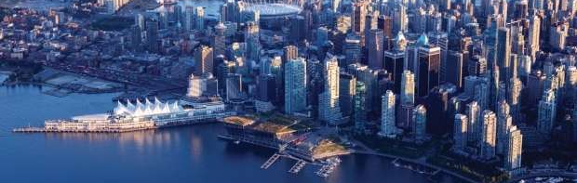

Tour ends with sweet memories.

PACKAGE COST & DETAILS
Category | Below prices are in USD
 | DBL | TRL/CWB | SGL | CNB |  | Quad
Deluxe | 4399 | 4269 | 5989 | 2819 |  | 4139
Inclusions:  - Deluxe Hotel Accommodations  - Breakfast, 12 Dinners  - Airport- Hotel-Airport Transfers  - Guided City Tour: TOR, MON, Quebec City, Ottawa, Vancouver  - Airfare: TOR-MON, CAL-VANC (incl taxes & 1 Check In bag per person)  - Entrance Tickets of: Hornblower Cruise, Journey behind the falls, CN Tower, Banff gondola ride, Peak to peak, Icefield Explorer + Skywalk, Capilano Suspension Bridge  - All taxes  - Maxim Tour Leader / Local Representative |  |  |  |  | Exclusions:  - International Airfare  - MON-CALG Internal Flight  - Meet & greet at airport  - Porterage, Laundry bills & other incidental charges  - Anything that is not mentioned in the inclusions part.
Departure Dates 2026:
MAY – 12
JUNE – 9
JULY – 21
Please note –
- Any Resort Fees/Destination Fees to be paid by guest directly at the hotel check in.
- Mandatory tips of $5.00 per person per day will be billed in the Invoice.

HOTELS:
City | Nts. | Deluxe Hotels OR SIMILAR
TOR | 03 | Hotel Four Point Sheraton TOR / Hotel Don Valley & Suites / Fairfield Marriott or similar
MON | 03 | Hotel Ramada Plaza / Fairfield Marriott / Courtyard Marriott or similar
BANF | 03 | Hotel Coast Canmore / Hotel Banff Park Lodge / Hotel Chateau Canmore or similar
VANC | 03 | Hotel Holiday Inn VANC / Hampton Inn / Four Point Sheraton or similar
BASIC INFORMATION:
Hotels | Transfer | Meal
Check in time: 4pm / Check out time: 11am | All on PVT basis | Breakfast: As provided by Hotel.
Breakfast time: 6:30 Am to 9:30 Am |  | Lunch: On Own
Incidental Charges Must be paid by clients |  | Dinner: Indian Veg / Non Veg / Jain meals

Booking Contact Details:
Mr. Rahul / Mr. Anand
- Indian Office: Mobile Number: + 91-9372740917 / +91-9769 35 13 67
- USA Number: 1- 404-232-0025 / 1-407-780-4855
- Email Address: inquiry@maximtours.net

GENERAL TERMS & CONDITIONS:
- Tour manager will be provided if the group Size is 15pax & above. Else the tour would be conducted with a Driver cum Tour Guide. Please check with us one week prior to departure for the group size.
- A valid credit card for each room would be required by respective passengers at all Hotels at the time of check in for a guarantee deposit.
- Airport transfer on Day 1 & Day 7 will be on Private / SIC basis. We will need the flight details and passenger local mobile number at least 15 working days ahead in order to provide excellent service towards passenger airport pick-ups.
- Tours will be conducted in a 55-seater Coach / 24-seater Mini Bus / 15- seater Mini Bus / Van with driver cum guide depending on the number of passengers confirmed.
- If the Group Size is over 15pax, there is a possibility where the transfer from LAX-SFO will be by Coach.
- In case, the passenger count per departure are 12 adults or below for any reason, then we can offer them any one of the below options –
  - Some City tours & sight seen will be on SIC basis
  - We can shift them to the next available departure date. Please check with us 30-days prior to start date of the tour.
  - Due to Less pax count the dinners will be served as a set Menu (No Buffet) or packed dinner delivered at the hotel.
- Child age 2-9 years. Above 9 years is considered as an adult.
- We reserve the right to use alternative accommodation, sightseeing tours and transfer of equal or higher standards.
- No refunds either in part or full will be made for any unused services in above package like ground transportation, meals, accommodation, and sightseeing tours. Any Meals missed due to flight timing will not be refunded.
- The Incidental charges are not included: for instance: Porterage, tips, laundry, telephone calls, alcohol/non-alcoholic beverages.
- Early check-In is not guaranteed. Every effort will be made for passengers coming in early but this are at the hotel’s discretion & availability.
- Passengers requiring Wheelchair assistance will have to make their own arrangements.
- Please note that some hotels require guests to give their Credit card/cash towards incidentals. No charges are levied unless guests use services not included in the package.
- Final working itinerary and vouchers will be sent by email 05 days prior to departure date for East Coast and West Coast respectively.
- Tour manager will be separate for East & West Canada.
- Seating Arrangement in the bus will be first come first serve
- Late Booking Fee: $50 per person (within 15 days of travel)

PAYMENT TERMS & CONDITIONS
- Booking Deposit Fees: USD 1000.00 per person
- Please note – There will be a supplement charge of USD 50.00 per person per transfer for arrivals and departures between 11pm and 6am.
- Cancellation Policy- 30days & above- Full refund 29-15 days- 50% Refund 14-0 days- 0% Refund
- Surcharges apply for any trade fair/special event in city.
- We will need full payment of the tour 30-days prior to departure date.
- Please note there would be a 3.5% service fee if payment is done by credit card.
- Please note that $35.00 wire transfer fees applies for all bank transaction.



