15 DAYS- CLASSIQUE CANADA

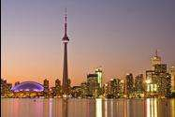
Day 01 - Arrive in Toronto
Welcome to Toronto! A fabulous waterfront city lying on the north shore of Lake Ontario, Toronto is Canada’s largest and most cosmopolitan city. Its breathtaking architecture, world class Theater, international sports, and beautiful waterfront setting make this a popular city to study in. Stroll around Harbor front Park with new international friends. Over 25 million people visit Toronto annually. Upon arrival, check-in to the hotel.

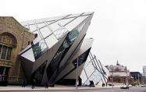
Day 02- Toronto City Tour
After breakfast, proceed for a City tour of Toronto, where you will explore the Hockey Hall of Fame, CN Tower, Rogers Centre, Air Canada Centre, Olympic Spirit, and Toronto’s Harbor front, St. Lawrence Market, the Entertainment District, Casa Loma, the Royal Ontario Museum, Bata Shoe Museum, Eaton Centre. (Meals: B)

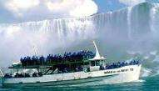
Day 03- Niagara Falls Day Tour
After breakfast, you will proceed towards Canada’s greatest Natural Wonder- Niagara Falls. You will visit the Horseshoe Falls, Table Rock, Floral Clock, Clifton Hill, and Niagara on the lake. We will board the famous boat, “Maid of the Mist,” which takes us close to the thundering falls and around the American and Horseshoe Falls (seasonal). Later we will proceed back to
Toronto. (Meals: B)
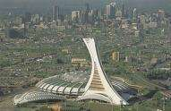
Day 04- Toronto- Montreal
Today we proceed by plane/train to Montreal. A city at the foot of Mount Royal, Montreal known for its majestic Churches, Olympic Stadium and exciting festivals. Upon arrival, check-in to the hotel. Spend the time at leisure.
(Meals: B)

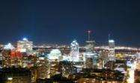
Day 05- Montreal City Tour
After breakfast, proceed for an exciting city tour of Montreal. Visit Old Montreal, Notre-Dame Basilica, Olympia Park, Mount Royal Park, St. Joseph's Oratory, Montreal Harbor, Chinatown, Place Ville Marie, City Hall, Bell Centre, Downtown Montreal and much more.(Meals: B)

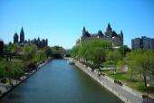
Day 06- Ottawa City Tour
After breakfast, travel from Montreal by motor coach and spend a day exploring beautiful and historic Ottawa, Canada's Capital. The City tour includes the Parliament Building, Supreme Court of Canada, National Arts Center, Rideau Canal, Ottawa City Hall, Rockcliffe Lookout, Dows Lake, Ornamental Gardens, Chinatown & Little Italy, and Farmers Byward Market. Later, drive back to Montreal. (Meals: B)

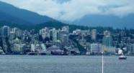
Day 07- Quebec City Tour& Montmorency Falls
After Breakfast, proceed for a day tour to Quebec City. Today, we will bring you through all the historical treasures of Quebec such as: Place Royale, Plains of Abraham, Parliament Building, Montmorency Falls, Ile D’ Orleans, Place D'Armes and many more. (Meals: B)

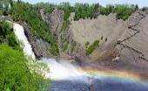
Day 08– Montreal- Calgary
Today we proceed by plane/train to Calgary, which is the largest city in the province of Alberta, Canada. It is located in the south of the province, in a region of foothills and high plains, approximately 80 km east of the front ranges of the Canadian Rockies. Upon arrival, check-in to the hotel. Spend rest of the day at leisure. (Meals: B)

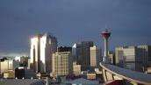
Day 09- Calgary City tour
After breakfast, you will proceed for a city tour of Calgary. Visit Calgary Tower, Old and New City Hall, Olympic Plaza, Fort Calgary Historic Park, Chinatown, Eau Claire Market Mall, Stephen Avenue, Devonian Garden, Stampede Park, Saddle dome, and much more. (Meals: B)

Day 10- Banff City Tour& Gondola Ride
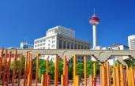
Today you will enjoy a stunning tour, which is a great way to see Banff and its surrounding areas from an amazing selection of perspectives. A full day excursion takes you from the city of Calgary into the Canadian Rockies through Alberta's foothills and ranching country to the resort town of Banff in the Rocky Mountains. Experience our stories of the people, geology, and the building of this mountain town. This day trip includes admission to the Banff Gondola, where an 8-minute gondola car takes you to the top of the mountain. (Meals: B)

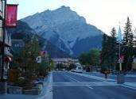
Day 11- Calgary - Vancouver
Today we proceed by plane/train to Vancouver, which is truly one of the world's most beautiful cities and one of the healthiest places to visit or live. It is a sophisticated, vibrant, fun loving, outdoor living city. Upon arrival, check in hotel and spend time at leisure. (Meals: B)


Day 12- Vancouver City Tour- Grouse Mountain- Suspension Bridge Tour
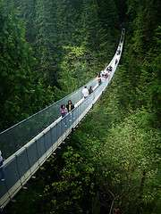
This all day tour combines Vancouver Highlights with the best of the North Shore: Capilano Suspension Bridge and Park and Grouse Mountain including the Grouse Mountain Sky ride to the top of the mountain. You’ll see Stanley Park, Chinatown, Gastown, English Bay and Yaletown downtown. You’ll also have plenty of time to explore Capilano Suspension Bridge, with its Tree Top Adventure, Cliff Walk and the amazing bridge itself. Then it’s up to the top of Grouse Mountain by gondola where you’ll have time to visit Coola and Grinder, the two orphaned Grizzly Bears, watch amazing lumberjacks and the Lumber Jack Show, Birds in Motion and the Theatre in the Sky. (Meals: B)

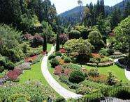
Day 13- Victoria & Butchart Garden Tour
Today you will enjoy a 90 minute cruise through the spectacular Gulf Islands. Watch for whales, sea lions and bald eagles. You will visit Butchart Gardens, which is fifty-five acres of flowers, trees, pathways and creeks. Featuring a sunken garden, a world famous rose garden and a wonderful restaurant serving High Tea daily, Butchart Gardens is one of the most beautiful and best maintained gardens in the world. Tour the city of Victoria and take a scenic drive along the coast and enjoy the views. Ride through the famous Oak Bayand Uplands residential areas plus the University of Victoria, Beacon Hill Park, Chinatown and Downtown. (Meals: B)

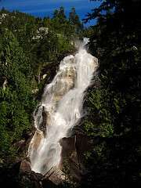
Day 14 - Vancouver - Whistler& Shannon Falls Tour
After breakfast, you will enjoy the breathtaking views and scenic stops along the thrilling Sea-To-Sky Highway. Feel the mist of the spectacular 335-meter Shannon Falls. When you get to Whistler, there is ample time to shop, dine, take the Peak 2 Peak gondola, ride a bike or stroll through the trails. Seasonally, ride the Gondola to the Peak of Whistler Mountain. Enjoy glacier, mountain and river views on your leisurely ride home. (Meals: B)

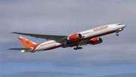
Day 15- Fly Out
After breakfast, we will depart for the airport to board your flight for next destination. (Meals: B)

PACKAGE COST & DETAILS
Category | 2 - 5 PAX (USD)
 | Double | Triple/CWB | Single | Child No Bed | Quad
Moderate | 4179 | 4139 | 5339 | 3029 | 3869
Deluxe | 5009 | 4849 | 6929 | 3079 | 4699

Inclusions:  - Hotel Accommodations  - Breakfast  - Airport- Hotel-Airport Transfers  - City Tour on SIC: Toronto, Ottawa, Montreal, Quebec City, Calgary, Banff, Vancouver  - Day trip to Niagara Falls with Maid of the Mist  - Day trip to Banff with Gondola Ride  - Day trip to Grouse Mountain & Capilano Suspension Bridge  - Day tour to Victoria & Butchart Garden  - Day tour to Whistler with Shannon Falls  - All tours & transfers on SIC  - All Taxes | Exclusions:  - International & Domestic Airfare  - Intercity travel by Flight / Bus / Train  - Meet & Greet at airport  - Any Destination Fees/Resort fees at any hotel  - Tips to guides & drivers  - Porterage, Laundry bills & other incidental charges  - For SIC tours – Hotel pick & drop not guaranteed. Client will have to arrange the transfer on its own for any SIC tours.  - Anything not mentioned in inclusions section
Optional cost per person:
- 2-5pax= Return PVT Airport trns Per Dest=
USD 35.00 per person

HOTELS WILL BE AS BELOW OR SIMILAR:
City | Nts. | Moderate Hotels | Deluxe Hotels
TOR | 03 | Hotel Holiday Inn Express / Hampton Inn | Hotel Four Point Sheraton / Edward
MON | 04 | Hotel Ramada / Hampton Inn | Hotel Crown Plaza / Sheraton MON
CAL | 03 | Hotel Holiday Inn Express / Ramada | Hotel Radisson / Hyatt Place
VANC | 04 | Hotel Holiday Inn Express /Ramada | Hotel Sandman / Holiday Inn

BASIC INFORMATION:
Hotels | Transfer/Sightseeing’s | Meal
Check in: 4pm / Check out: 11am | 2-5 Pax – SIC basis | Breakfast: As provided by Hotel.
Breakfast time: 6:30 Am to 9:30 Am
Incidental Charges Must be paid by clients

TERMS & CONDITIONS:
- All rates are based on minimum 2Pax traveling together at all tours.
- Surcharges apply for any trade fair/special event/weekend in LAS or any other event in city.
- Child age à 2-9 years. Above 9 years is considered as an adult.
- All rates and availability are subject to change at the time of booking.
- Some events are seasonal like Maid of the Mist, Cave of the Winds, Beast ride, Yosemite Park, Lake Tahoe etc. (Will be closed for winter)
- Optional Meals do not include transfers; the meal will be delivered to your hotel if the restaurant is not within walking distance.
- SIC Tour / Transfer pick-up depends on hotel location, if hotel is outside of pick-up zone, clients will have to make own arrangements.
- We reserve the right to use alternative accommodation, sightseeing tours and transfer of equal or higher standard.
- No refunds either in part or full will be made for any unused services in above package like ground transportation, meals, accommodation, sightseeing tours.
- We are not responsible for any missed breakfast due to flight timings.
- No Intercity surface transfers are included unless specified in the package.
- We are not responsible for any baggage charges by any airlines for the clients.
- Payment for the tour must be made as per the invoice, payment terms & conditions.

