20 DAYS – ALL OF USA

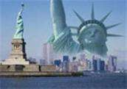
Day 01 - Arrive at New York
Welcome to the "Big Apple," the "City That Never Sleeps"—New York is a city of superlatives: America's biggest; its most exciting; its business and cultural capitals; the nation's trendsetter. For more than a century, it has been one of the world's major centers of commerce and finance. Upon arrival at the airport, you will be transferred to the hotel.

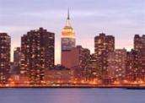
Day 02 - New York City Tour
After breakfast, we proceed for a City Tour of New York. The sightseeing will include USA’s famous landmark, “Statue of Liberty.” We will take a ferry ride to Liberty Island for a spectacular view of the New York City Skyline. Next, we experience the view of a lifetime from the 86th floor of the Empire State Building. Later in the day we will see Rockefeller Center, Wall Street, Ground Zero and Central Park, Times Square, United Nations and Trump Tower. (Meal: B)

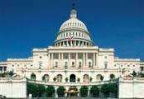
Day 03- New York - Washington D.C.
Today, we proceed by plane/train/road to Washington D.C., capital of the United States of America and Guide to the Historic Neighborhoods and Monuments. Other than the federal government, tourism is D.C.'s biggest industry. The city attracts almost twenty million visitors each year. After checking in at the hotel, you will explore the capital city of US. See the White House, Lincoln Memorial, Supreme Court, the Capitol Building, the Smithsonian Air and Space museum, Union Station, World War II Memorial Building, Pentagon Building and Washington monument.(Meal: B)

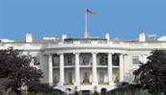
Day 04- Washington - Buffalo - USA side Niagara Falls
Today, we proceed by plane/train/road to Buffalo, to view the world famous falls, which form one of the natural Wonders of the World. (Meal: B)

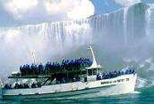
Day 05- USA side Niagara Falls
We will board the famous boat, “Maid of the Mist,” which takes us close to the thundering falls and around the American and Horseshoe Falls (seasonal). Return to the hotel to freshen up after your damp ride. (Meal: B)

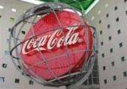
Day 06 - Buffalo - Atlanta
Today, we proceed by plane/train/road to Atlanta. As the "New Capital of the South, with fine dining, museums, theater, attractions and world-class shopping, Atlanta has something for everyone. Spend some time in shopping in one of the numerous malls or head to downtown for an evening out. (Meal: B)

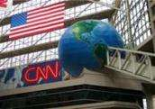
Day 07 - Atlanta City Tour
Enjoy today’s city tour and turn your sights to landmarks that tell the story of Atlanta’s history and growth into one of the South’s most progressive cities. You will visit Wold of Coca Cola – a tribute to the famous drink, take a CNN News Studio Tour, visit the worlds largest Aquarium. (Meal: B)

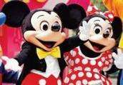
Day 08 - Atlanta - Orlando
Today, we proceed by plane/train/road to Orlando. Orlando is the sixth largest city of Florida and is also known to be its largest inland city. The presence of the Disney World theme park has made this city a well-known vacation spot. This city is said to welcome more than 52 million tourists every year. Upon arrival, transfer to your hotel. (Meal: B)

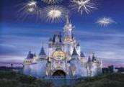
Day 09 - Orlando - Walt Disney- Magic Kingdom
Today you will visit the Magic Kingdom, which covers 107 acres and was opened on October 1, 1971. It's been dubbed "The Most Magical Place on Earth!" and is home to seven themed lands, and dozens of attractions that appeal to all ages. It is the place where storybook fantasy is everyday reality, and Disney classics are brought to life. From the moment you step onto Main Street USA, you are transported to a place where the cares of the outside world seem to magically melt away. (Meal: B)

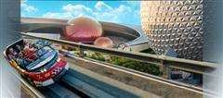
Day 10 - Orlando - Epcot Center
Begin your day at the Epcot center, where you can touch the future and travel the world with an amazing array of attractions and live performances. This is an area of 260 acres devoted to past achievements and the future of technology. World showcase offers a kind of permanent World Fair, with pavilions devoted to eleven countries. (Meals: B)

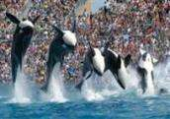
Day 11 - Orlando - Sea World
Today you will visit the world's largest Marine Park, Sea World. Here, you shall discover many attractions. We dare you to take a one-of-a kind water coaster thrill ride through the mysterious lost city of Atlantis. Soar through danger on a jet copter ride to the Wild Arctic. At Sea World, touch, feed or get face to face with awesome and amazing wild animals, and get in on all the action that draws you back again and again! (Meal: B)

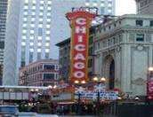
Day 12- Orlando - Chicago
Today, we proceed by plane/train/road to Chicago, often called The Windy City and The City of Broad Shoulders. Today the city's attractions bring 44.2 million visitors annually. Chicago is the largest city by population in the state of Illinois and the American Midwest. It is a dominant center of finance, industry and culture in the region. The city, for much of its history, has been known informally as America's "Second City." Upon arrival, transfer to the hotel. (Meal: B)

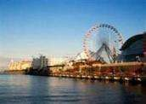
Day 13 - Chicago City Tour
After breakfast, we proceed for a city tour that includes Sears Tower, Millennium Park, Whacker South, Lake Shore Drive, Navy Pier, Magnificent Mile, Downtown, Art Institute, River North and much more. (Meal: B)

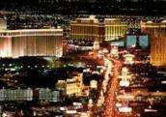
Day 14 - Chicago - Las Vegas
Today, we proceed by plane/train to Las Vegas. On arrival, transfer to your hotel. In the evening, we proceed for the city tour in Las Vegas experiencing the spectacular Colorful Dancing Fountain water fountains of the Bellagio, the Pirate Ships at Treasure Island, Stratosphere Tower, Downtown Vegas, and of course Fremont street, where over 12 million lights create a free show with pumping music. (Meal: B)

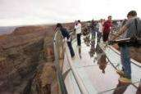
Day 15 - Grand Canyon (Optional)
Spend the day at leisure OR take the Grand Canyon Tour Bus or Air (OPTIONAL). Don’t forget the new Wonder of the West, The Skywalk. In the evening, take the Las Vegas Night Flight (OPTIONAL), a Helicopter Ride over dazzling night time Vegas, take in a fabulous Show or visit any of the free shows such as the Sirens of Treasure Island and much more.

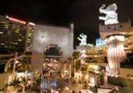
Day 16 -Las Vegas - Los Angeles
Today, we proceed by plane/train/road to Los Angeles. Later, enjoy a city tour of Los Angeles. We will drive you through the “Entertainment capital of the world, ”Hollywood, Hollywood Walk of Fame, Beverly Hills, Grumman Chinese Theater, Sunset Strip, Rodeo Drive for the world’s most expensive shopping, and Chinatown for some good bargains.

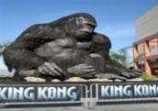
Day 17 -Los Angeles- Universal Studios
Join us today for a tour of Universal Studios, which has always been known for its innovative rides and attractions and is designed to let visitors experience the movies like never before. A trip to Universal is like a trip into the heart of Hollywood. With films and TV shows always in production, one never knows who they might see wandering the sidewalks of the park. (Meals: B)

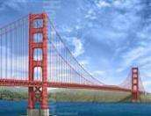
Day 18 - Los Angeles - San Francisco
Today, we proceed by plane/train/road to San Francisco, one of the few North American cities to achieve the legendary status of such places as Paris or London. You will visit the famous Golden Gate Bridge, with the world’s highest bridge towers. Continue on to Twin Peaks, Lombard Street, Cable Car, Pier 39, Nob Hill, Civic Center, Union Square, Fisherman’s Wharf, Palace of Fine Arts& other highlights. (Meal: B)

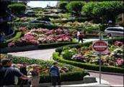
Day 19- San Francisco City Tour
Today, we proceed on a sightseeing tour of San Francisco. You will visit the famous Golden Gate Bridge, with the world’s highest bridge towers. Continue on to Twin Peaks, Lombard Street, Cable Car, Pier 39, Nob Hill, Civic Center, Union Square, Fisherman’s Wharf, Palace of Fine Arts& other highlights. (Meal: B)

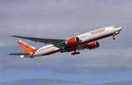
Day 20- Departure from San Francisco
After breakfast, spend some time at leisure. Depart for the airport to board your flight for next destination. (Meals: B)

PACKAGE COST & DETAILS
Category | 2 - 5 PAX (USD)
 | Double | Triple/CWB | Single | Child No Bed | Quad
Moderate | 4949 | 4739 | 6619 | 3279 | 4529
Deluxe | 5779 | 5569 | 8279 | 3359 | 5359

Inclusions:  - Hotel Accommodations  - Breakfast (Except LAS)  - Airport- Hotel-Airport Transfers  - City Tour on SIC: New York, Washington D.C, Atlanta, Chicago, San Francisco, Las Vegas, Los Angeles  - Entrance Tickets with transfers: Statue of Liberty, Empire State Building, CNN Studio Tour, Georgia Aquarium, World of Coca Cola, Sears Tower, Sea World, Epcot Center, Magic Kingdom, Universal Studios  - Entrance Tickets without transfers: Maid of the Mist (walking distance from hotel)  - All tours & transfers on SIC  - All Taxes | Exclusions:  - International & Domestic Airfare  - Intercity travel by Flight / Bus / Train  - Breakfast & Resort Fees in LAS  - Any Destination Fees/Resort fees at any hotel  - Supplement cost applicable for Weekend in LAS/NIA  - Meet & greet at airport  - Tips to guides & drivers  - Porterage, Laundry bills & other incidental charges  - For SIC tours – Hotel pick & drop not guaranteed. Client will have to arrange the transfer on its own for any SIC tours.  - Anything not mentioned in inclusions section
Optional cost per person:
- Grand Canyon West Bus Tour & Skywalk = 199.00
- Grand Canyon Air tour = USD 199.00
- Las Vegas Helicopter ride = USD 149.00
- Surface transfer from LAS-LAX (SIC)= USD 89.00 pp
- 2-5pax= Return PVT Airport trns Per Dest=
USD 35.00 per person

HOTELS WILL BE AS BELOW OR SIMILAR
City | Nts | Moderate Hotels | Deluxe Hotels
NYC | 02 | Hotel Fairfield Inn Manhattan / Holiday Inn | Hotel Doubletree Manhattan / Hyatt Place Manhattan
WAS | 01 | Hotel Comfort Inn / Best Western | Hotel Doubletree Dulles / Wyndham Garden
NIA | 02 | Hotel Quality Inn at Falls / Laquinta Inn | Hotel Hyatt Place / Holiday Inn
ATL | 02 | Hotel Drury Inn / Holiday Inn | Hotel Doubletree / Embassy Suites
ORL | 04 | Hotel Fairfield Inn / Comfort Inn | Hotel Four Point Sheraton / Courtyard Marriott
CHI | 02 | Hotel Holiday Inn O'Hare / Wingate Inn | Edward Hotel /Hyatt Place
LAS | 02 | Hotel Circus Circus / Excalibur / Westgate | Hotel Luxor / Park MGM
LAX | 02 | Hotel Holiday Inn / Fairfield Inn LAX | Hotel Doubletree Norwalk / Commerce Casino Hotel
SFO | 02 | Hotel Holiday Inn SFO / La Quinta Hayward | Hotel Embassy Suites SFO / Crown Plaza / Holiday Inn

BASIC INFORMATION:
Hotels | Transfer/Sightseeing’s | Meal
Check in: 4pm / Check out: 11am | 2-5 Pax – SIC basis | Breakfast: As provided by Hotel.
Breakfast time: 6:30 Am to 9:30 Am
Incidental Charges Must be paid by clients

TERMS & CONDITIONS:
- All rates are based on minimum 2Pax traveling together at all tours.
- Surcharges apply for any trade fair/special event/weekend in LAS or any other event in city.
- Child age à 2-9 years. Above 9 years is considered as an adult.
- All rates and availability are subject to change at the time of booking.
- Some events are seasonal like Maid of the Mist, Cave of the Winds, Beast ride, Yosemite Park, Lake Tahoe etc. (Will be closed for winter)
- Optional Meals do not include transfers; the meal will be delivered to your hotel if the restaurant is not within walking distance.
- SIC Tour / Transfer pick-up depends on hotel location, if hotel is outside of pick-up zone, clients will have to make own arrangements.
- We reserve the right to use alternative accommodation, sightseeing tours and transfer of equal or higher standard.
- No refunds either in part or full will be made for any unused services in above package like ground transportation, meals, accommodation, sightseeing tours.
- We are not responsible for any missed breakfast due to flight timings.
- No Intercity surface transfers are included unless specified in the package.
- We are not responsible for any baggage charges by any airlines for the clients.
- Payment for the tour must be made as per the invoice, payment terms & conditions.

