3 DAYS – CALGARY CITY BREAK

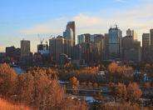
Day 01 – Calgary

Welcome to Calgary, a cosmopolitan Alberta city with numerous skyscrapers, owes its rapid growth to its status as the centre of Canada’s oil industry. Upon arrival, check-in to the hotel.

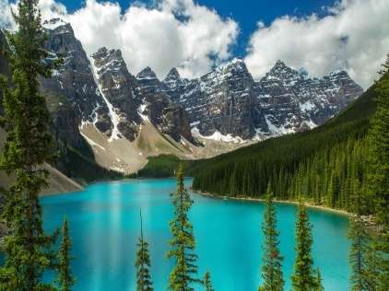
Day 02 - Banff City Tour & Gondola Ride
Today, you will enjoy a stunning tour, which is a great way to see Banff and its surrounding areas from an amazing selection of perspectives. Excursion takes you from the city of Calgary into the Canadian Rockies through Alberta's foothills and ranching country to the resort town of Banff in the Rocky Mountains. Experience our stories of the people, geology, and the building of this mountain town. Trip includes admission to the Banff Gondola, where an 8-minute gondola car takes you to the top of the mountain. (Meals: B)

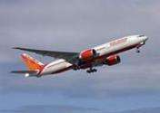
Day 03- Calgary - Fly Out
Today, we finish our trip and get ready to fly back home or to the
Next destination.(Meals: B)



PACKAGE COST & DETAILS
Category | 2 - 5 PAX (USD) / per person
 | Double | Triple/CWB | Single | Child No Bed | Quad
Moderate | 659.00 | 639.00 | 829.00 | 569.00 | 619.00
Deluxe | 769.00 | 749.00 | 989.00 | 609.00 | 729.00

Inclusions:  - Hotel Accommodations  - Breakfast  - Airport- Hotel-Airport Transfers  - Day trip to Banff with Gondola Ride  - All tours & transfers on SIC  - All Taxes | Exclusions& Important notes:  - International & Domestic Airfare  - Intercity travel by Flight / Bus / Train  - Meet & Greet at airport  - Tips to guides & drivers  - Porterage, Laundry bills & other incidental charges  - For SIC tours – Hotel pick & drop not guaranteed  - Anything not mentioned in inclusions section

HOTELS WILL BE AS BELOW OR SIMILAR:
City | Nts. | Moderate Hotels | Deluxe Hotels
CAL | 02 | Holiday Inn Express / Ramada or similar | Radisson / Wyndham Garden or similar

BASIC INFORMATION:
Hotels | Transfer/Sightseeing’s | Meal
Check in: 4pm / Check out: 11am | 2-5Pax – SIC basis | Breakfast: As provided by Hotel.
Breakfast time: 6:30 Am to 9:30 Am
Incidental Charges Must be paid by clients

TERMS & CONDITIONS:
- All rates are based on minimum 2Pax traveling together at all tours.
- Surcharges apply for any trade fair/special event/weekend in LAS or any other event in city.
- Child age 2-9 years. Above 9 years is considered as an adult.
- All rates and availability are subject to change at the time of booking.
- Some events are seasonal like Maid of the Mist, Cave of the Winds, Beast ride, Yosemite Park, Lake Tahoe etc. (Will be closed for winter)
- Optional Meals do not include transfers; the meal will be delivered to your hotel if the restaurant is not within walking distance.
- SIC Tour / Transfer pick-up depends on hotel location, if hotel is outside of pick-up zone, clients will have to make own arrangements.
- We reserve the right to use alternative accommodation, sightseeing tours and transfer of equal or higher standard.
- No refunds either in part or full will be made for any unused services in above package like ground transportation, meals, accommodation, sightseeing tours.
- We are not responsible for any missed breakfast due to flight timings.
- No Intercity surface transfers are included unless specified in the package.
- We are not responsible for any baggage charges by any airlines for the clients.
- Payment for the tour must be made as per the invoice, payment terms & conditions.

