3 DAYS – MONTREAL (CITY BREAK)

Day 01 –Montreal
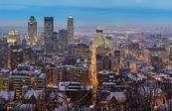
Welcome to Montreal. A city at the foot of Mount Royal, Montreal is known for its majestic Churches, Olympic Stadium and exciting festivals. Upon arrival, check-in to the hotel.

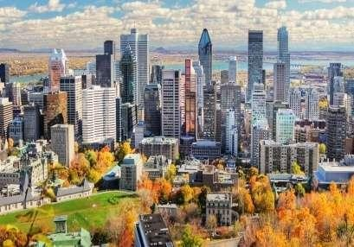
Day 02 – Montreal City Tour
After breakfast, Later proceed for an exciting city tour of Montreal. Visit Old Montreal, Notre-Dame Basilica, Olympia Park, Mount Royal Park, St. Joseph's Oratory, Montreal Harbor, Chinatown, Place Ville Marie, City Hall, Bell Centre, Downtown Montreal and much more. (Meals: B)

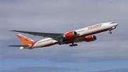
Day 03 - Montreal - Fly Out
Today we finish our trip and get ready to fly back home or to the next Destination. (Meals: B)



PACKAGE COST & DETAILS

Category | 2 - 5 PAX (USD) / per person
 | Double | Triple/CWB | Single | Child No Bed | Quad
Moderate | 399.00 | 379.00 | 519.00 | 319.00 | 359.00
Deluxe | 499.00 | 479.00 | 699.00 | 369.00 | 459.00

Inclusions:  - Hotel Accommodations  - Breakfast  - Airport- Hotel-Airport Transfers  - City Tour on SIC: MON  - Admission Tickets: Notre Dame Basilica  - All tours & transfers on SIC  - All Taxes | Exclusions:  - International & Domestic Airfare  - Intercity travel by Flight / Bus / Train  - Meet & Greet at airport  - Tips to guides & drivers  - Porterage, Laundry bills & other incidental charges  - For SIC tours – Hotel pick & drop not guaranteed  - Anything not mentioned in inclusions  section
Optional Tours:
- Day trip to Quebec & Montmorency Falls
= USD 199.00 per person

HOTELS WILL BE AS BELOW OR SIMILAR:
City | Nts. | Moderate Hotels | Deluxe Hotels
MON | 02 | Hotel Ramada / Hampton Inn | Hotel Crown Plaza / Sheraton MON
BASIC INFORMATION:
Hotels | Transfer/Sightseeing’s | Meal
Check in: 4pm / Check out: 11am | 2-5 Pax – SIC basis | Breakfast: As provided by Hotel.
Breakfast time: 6:30 Am to 9:30 Am
Incidental Charges Must be paid by clients

TERMS & CONDITIONS:
- All rates are based on minimum 2Pax traveling together at all tours.
- Surcharges apply for any trade fair/special event/weekend in LAS or any other event in city.
- Child age ? 2-9 years. Above 9 years is considered as an adult.
- All rates and availability are subject to change at the time of booking.
- Some events are seasonal like Maid of the Mist, Cave of the Winds, Beast ride, Yosemite Park, Lake Tahoe etc. (Will be closed for winter)
- Optional Meals do not include transfers; the meal will be delivered to your hotel if the restaurant is not within walking distance.
- SIC Tour / Transfer pick-up depends on hotel location, if hotel is outside of pick-up zone, clients will have to make own arrangements.
- We reserve the right to use alternative accommodation, sightseeing tours and transfer of equal or higher standard.
- No refunds either in part or full will be made for any unused services in above package like ground transportation, meals, accommodation, sightseeing tours.
- We are not responsible for any missed breakfast due to flight timings.
- No Intercity surface transfers are included unless specified in the package.
- We are not responsible for any baggage charges by any airlines for the clients.
- Payment for the tour must be made as per the invoice, payment terms & conditions.

