3 DAYS – TORONTO (CITY BREAK)

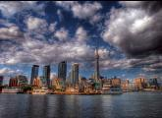
Day 01 - Arrive in Toronto
Welcome to Toronto! A fabulous waterfront city lying on the north shore of Lake Ontario, Toronto is Canada’s largest and most cosmopolitan city. Upon arrival, check-in to the hotel.

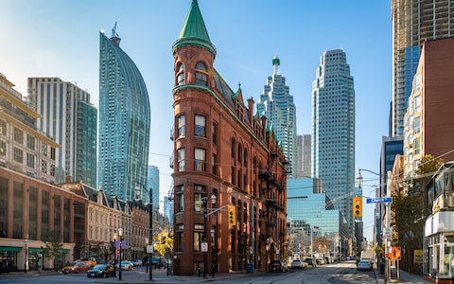
Day 02-Toronto City tour
After breakfast, today proceed for a City Tour of Toronto, where you will explore the Hockey Hall of Fame, CN Tower, Rogers Centre, Air Canada Centre, Olympic Spirit, Toronto's Harbour front, St. Lawrence Market, the Entertainment District, Casa Loma, the Royal Ontario Museum, Bata Shoe Museum, and Eaton Centre. (Meals: B)

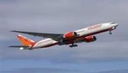
Day 03 - Totonto- Fly Out
Today we finish our trip and get ready to fly back home or to the next
Destination. (Meals: B)

PACKAGE COST & DETAILS

Category | 2 - 5 PAX (USD) / per person
 | Double | Triple/CWB | Single | Child No Bed | Quad
Moderate | 439.00 | 419.00 | 569.00 | 349.00 | 399.00
Deluxe | 549.00 | 529.00 | 769.00 | 439.00 | 509.00

Inclusions:  - Hotel Accommodations  - Breakfast  - Airport- Hotel-Airport Transfers  - City Tour on SIC: Toronto  - Admission Tickets: CN Tower  - All tours & transfers on SIC  - All Taxes | Exclusions:  - International & Domestic Airfare  - Intercity travel by Flight / Bus / Train  - Meet & Greet at airport  - Tips to guides & drivers  - Porterage, Laundry bills & other incidental charges  - For SIC tours – Hotel pick & drop not guaranteed  - Anything not mentioned in inclusions section
Optional Tours:
Niagara Falls Day Tour with Cruise (Seasonal) = USD 199.00 per person

HOTELS WILL BE AS BELOW OR SIMILAR:
City | Nts. | Moderate Hotels | Deluxe Hotels
TOR | 02 | Hotel Holiday Inn Express / Fairfield Inn | Hotel Four Point Sheraton Mississauga / Crown Plaza

BASIC INFORMATION:
Hotels | Transfer/Sightseeing’s | Meal
Check in: 4pm / Check out: 11am | 2-5 Pax – SIC basis | Breakfast: As provided by Hotel.
Breakfast time: 6:30 Am to 9:30 Am
Incidental Charges Must be paid by clients

TERMS & CONDITIONS:
- All rates are based on minimum 2Pax traveling together at all tours.
- Surcharges apply for any trade fair/special event/weekend in LAS or any other event in city.
- Child age à 2-9 years. Above 9 years is considered as an adult.
- All rates and availability are subject to change at the time of booking.
- Some events are seasonal like Maid of the Mist, Cave of the Winds, Beast ride, Yosemite Park, Lake Tahoe etc. (Will be closed for winter)
- Optional Meals do not include transfers; the meal will be delivered to your hotel if the restaurant is not within walking distance.
- SIC Tour / Transfer pick-up depends on hotel location, if hotel is outside of pick-up zone, clients will have to make own arrangements.
- We reserve the right to use alternative accommodation, sightseeing tours and transfer of equal or higher standard.
- No refunds either in part or full will be made for any unused services in above package like ground transportation, meals, accommodation, sightseeing tours.
- We are not responsible for any missed breakfast due to flight timings.
- No Intercity surface transfers are included unless specified in the package.
- We are not responsible for any baggage charges by any airlines for the clients.
- Payment for the tour must be made as per the invoice, payment terms & conditions.
.



