6 DAYS – EXOTIC ARGENTINA
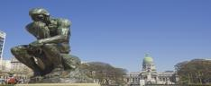
Day 01 -Buenos Aires
Welcome in Buenos Aires, the capital of Argentina. After completing all the immigration formalities, you will be transferred to the hotel. Buenos Aires is, with over 11 million inhabitants, one of the largest cities in Argentina. Overnight in Buenos Aires.

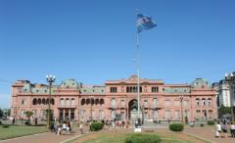
Day 02 - Buenos Aires
After breakfast, we start the city tour of Buenos Aires. Visit "Plaza de Mayo," the Pink House, the Buenos Aires Cathedral, the 9 of July Avenue, the Colon Theatre, La Boca neighborhood with the traditional "Caminito Street," "San Martin Plaza," Recoleta Cemetery, and the Palermo Woods. In the afternoon, we will tour the Tigre and Parana’s Delta River. Then, return by bus along the Panamerican Highway to the city of Buenos Aires. Overnight in Buenos Aires. (Meals: B)

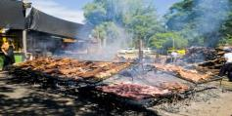
Day 03- Buenos Aires- Fiesta Gaucha tour
After breakfast, enjoy a full day Fiesta Gaucha Tour at Estancia Santa Susana, and meet 'gauchos' in their own environment. Ride to the outskirts of the city into the countryside, the 'pampas', cradle of the 'gaucho' and the rich 'gaucho' tradition. After dinner, proceed to enjoy the LA VENTANA, TANGO SHOW. Overnight in Buenos Aires. (Meals: B)

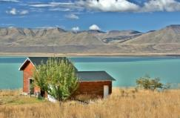
Day 04 - Buenos Aires -El Calafate
Today after breakfast, depart for El Calafate. The city is located at the base of Calafate Hill on the shore of the Argentinian Lake. In the early 20th century, the Patagonian trails had wagon stops every three leagues, the average distance covered in a day's journey by a driven wagon. These inevitable stops were named by the wagon drivers: "El Bote," "El Calafate," and "El Centinela." The name "El Calafate" comes from the dense calafate (berberis genus) shrubbery that grew on this alluvial plain. Check-into the hotel upon arrival.(Meals: B)

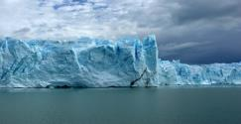
Day 05 -El Calafate - Full Day Excursion to Perito Moreno Glacier
After breakfast, proceed to the fascinating landscape of Argentinia's Perito Moreno glacier on a full day tour from El Calafate. Explore glacier streams, small lagoons, gullies, crevasses and plenty of ice formations on this one of a kind South American experience. Learn about the general glaciology of the region as well as a particular phenomenon that happens in the Perito Moreno Glacier.(Meals: B)
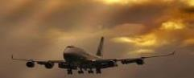
Day 06-Departure
Transfer to the airport to board the flight for your next destination.(Meals: B)


PACKAGE COST & DETAILS
Category | 2 - 5 PAX (USD)
 | DBL | TRL/CWB | SGL | CNB | Quad
Deluxe | 1859 | 1809 | 2329 | 1399 | 1749

Inclusions:  - Deluxe Hotel Accommodations  - Breakfast  - Airport- Hotel-Airport Transfers  - City Tour on SIC: Buenos Aires  - Entrance Tickets with transfers:  - Tigre and Parana’s Delta River  - Tango Show  - Fiesta Gaucho Tour  - Full Day Excursion to Perito Moreno Glacier  - All tours & transfers on SIC  - All Taxes | Exclusions:  - International & Domestic Airfare  - Meet & Greet at airport  - Any Destination Fees/Resort fees at any hotel  - Tips to guides & drivers  - Porterage, Laundry bills & other incidental charges  - For SIC tours – Hotel pick & drop not guaranteed. Client will have to arrange the transfer on its own for any SIC tours.  - Anything not mentioned in inclusions section

HOTELS WILL BE AS BELOW OR SIMILAR:
City | Nts. | Deluxe Hotels
Buenos Aires | 03 | Holiday Inn / Conte / Bel Air or similar
El Calafate | 02 | Hotel Mirador / Calafate Parque or similar

BASIC INFORMATION:
Hotels | Transfer/Sightseeing’s | Meal
Check in time: 4pm / Check out time: 11am | 2-5 Pax – SIC basis | Breakfast: As provided by Hotel.
Breakfast time: 6:30 Am to 9:30 Am
Incidental Charges Must be paid by clients

TERMS & CONDITIONS:
- All rates are based on minimum 2Pax traveling together at all tours.
- Surcharges apply for any trade fair/special event/weekend in LAS or any other event in city.
- Child age à 2-9 years. Above 9 years is considered as an adult.
- All rates and availability are subject to change at the time of booking.
- Some events are seasonal like Maid of the Mist, Cave of the Winds, Beast ride, Yosemite Park, Lake Tahoe etc. (Will be closed for winter)
- Optional Meals do not include transfers; the meal will be delivered to your hotel if the restaurant is not within walking distance.
- SIC Tour / Transfer pick-up depends on hotel location, if hotel is outside of pick-up zone, clients will have to make own arrangements.
- We reserve the right to use alternative accommodation, sightseeing tours and transfer of equal or higher standard.
- No refunds either in part or full will be made for any unused services in above package like ground transportation, meals, accommodation, sightseeing tours.
- We are not responsible for any missed breakfast due to flight timings.
- No Intercity surface transfers are included unless specified in the package.
- We are not responsible for any baggage charges by any airlines for the clients.
- Payment for the tour must be made as per the invoice, payment terms & conditions.

