7 DAYS– AMAZING TEXAS (VAN TOUR)
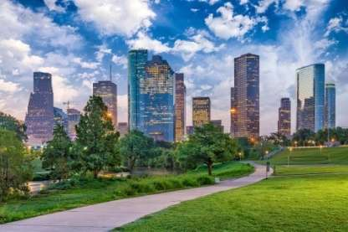
Day 01-Houston

Welcome to Houston, a large metropolis in Texas, extending to Galveston Bay. It’s closely linked with the Space Center Houston, the coastal visitor center at NASA’s astronaut training and flight control complex. Transfer to your hotel upon arrival.

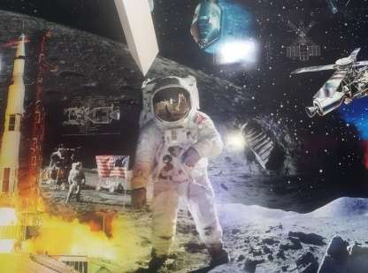
Day 02 –Houston – NASA Space Center + City Tour
After breakfast, visit Mission Control, Rocket Park, Independence Plaza, and the astronaut training facility. See popular landmarks around Houston, stopping briefly for photos during a sightseeing tour. With a map and instructions, enjoy the flexibility to explore the space center on your own time, without the stress of rushing. (Meals: B)

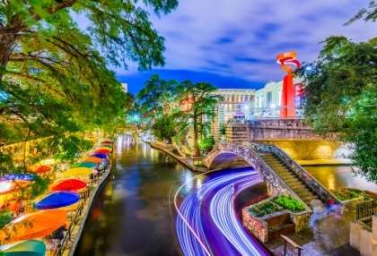
Day 03 – Houston – San Antonio
After breakfast we depart to San Antonio by road, a major city in south-central Texas with a rich colonial heritage. Transfer to your hotel upon arrival. Later explore the city & learn about San Antonio's history, culture, architecture and more as you pass by the Alamo, HemisFair Park, Tower of the Americas and Cathedral of San Fernando, then browse the shops at the Rivercenter Mall along the River Walk. (Meals: B)

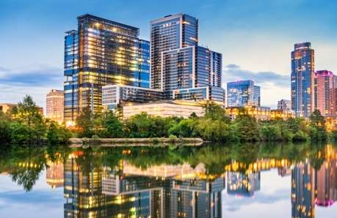
Day 04 –San Antonio - Austin
After breakfast we depart to Austin by road. Transfer to your hotel upon arrival. Later visit the Seaholm Power District and Texas State Capitol, cruise Congress Avenue, and stop for selfies with statues of two of Austin's most famous musicians. Wrap up your tour at Auditorium Shores, and take in fantastic skyline views.
(Meals: B)

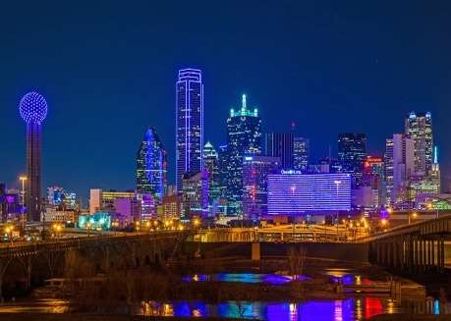
Day 05-Austin – Dallas
After breakfast, we depart to Dallas by road, a modern metropolis in north Texas, is a commercial and cultural hub of the region. Downtown’s Sixth Floor Museum at Dealey Plaza commemorates the site of President John F. Kennedy’s assassination in 1963. In the Arts District, the Dallas Museum of Art and the Crow Collection of Asian Art cover thousands of years of art. The sleek Nasher Sculpture Center showcases contemporary sculpture. Transfer to your hotel upon arrival. (Meals: B)

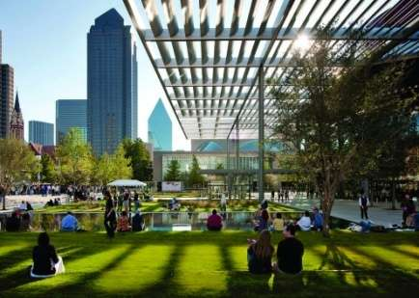
Day 06-Dallas City Tour + JFK
Visit top Dallas highlights on a tour that explores local history, colorful neighborhoods, and the tragic story of President John F. Kennedy's assassination. You'll tick off a long list of highlights, then follow the paths of the Kennedys and John Harvey Oswald, the man accused of killing the president. (Meals: B)

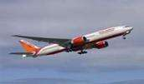
Day 07-Departure from Dallas
After breakfast, we will depart for the airport to board your flight for the next
Destination. (Meals: B)

PACKAGE COST & DETAILS
Category | 6-9 PAX (USD) / Per person |  |  |  |  |  | 10-13 PAX (USD) / Per person
 | Double | Triple/CWB | Single | CNB | Quad |  | Double | Triple/CWB | Single | CNB | Quad
Deluxe | 2749 | 2689 | 3349 | 2159 | 2619 |  | 2199 | 2139 | 2799 | 1649 | 2069

Inclusions:  - Deluxe Hotel Accommodations  - Breakfast  - Airport- Hotel-Airport Transfers  - Intercity Surface transfers; HOU-SAT-AUS-DFW  - City Tours: HOU, SAT, AUS, DFW  - Entrance Tickets with transfers: NASA Space Center  - The Sixth Floor Museum at Dealey Plaza  - All Taxes  - All transfers & sight seen on PVT basis | Exclusions:  - International & Domestic Airfare  - Meet & Greet at airport  - Tips to guides & drivers  - Porterage, Laundry bills & other incidental charges  - For SIC tours – Hotel pick & drop not guaranteed  - Anything not mentioned in inclusions section  - Any Destination Fees/Resort fees at any hotel
Optional cost per person:
- Sea World San Antonio Admission = USD 99.00 per person
- Sea Life Dallas = USD 65.00 per person

HOTELS WILL BE AS BELOW OR SIMILAR:
City | Nts. | Deluxe Hotels
Houston | 2 | Hotel Embassy Suites / Residence Inn / Hyatt Place
San Antonio | 1 | Hotel Residence Inn San Antonio / Doubletree San Antonio / Four Point Sheraton
Austin | 1 | Crown Plaza / Doubletree / Courtyard
Dallas | 2 | Hotel Hilton Garden Inn /Springhill Suites / Hyatt Place

BASIC INFORMATION:
Hotels | Transfer/Sightseeing’s | Meal
Check in: 4pm / Check out: 11am | PVT Basis (Sprinter Van) | Breakfast: As provided by Hotel.
Breakfast time: 6:30 Am to 9:30 Am
Incidental Charges Must be paid by clients

TERMS & CONDITIONS:
- All rates are based on minimum 2Pax traveling together at all tours.
- Surcharges apply for any trade fair/special event/weekend in LAS or any other event in city.
- Child age à 2-9 years. Above 9 years is considered as an adult.
- All rates and availability are subject to change at the time of booking.
- Some events are seasonal like Maid of the Mist, Cave of the Winds, Beast ride, Yosemite Park, Lake Tahoe etc. (Will be closed for winter)
- Optional Meals do not include transfers; the meal will be delivered to your hotel if the restaurant is not within walking distance.
- SIC Tour / Transfer pick-up depends on hotel location, if hotel is outside of pick-up zone, clients will have to make own arrangements.
- We reserve the right to use alternative accommodation, sightseeing tours and transfer of equal or higher standard.
- No refunds either in part or full will be made for any unused services in above package like ground transportation, meals, accommodation, sightseeing tours.
- We are not responsible for any missed breakfast due to flight timings.
- No Intercity surface transfers are included unless specified in the package.
- We are not responsible for any baggage charges by any airlines for the clients.
- Payment for the tour must be made as per the invoice, payment terms & conditions.
- YELLOWSTONE is open from May 01 – November 01, 2016


