7 DAYS– AMAZING TEXAS
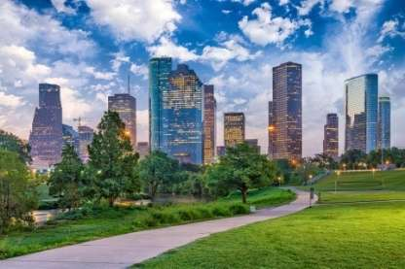
Day 01-Houston

Welcome to Houston, a large metropolis in Texas, extending to Galveston Bay. It’s closely linked with the Space Center Houston, the coastal visitor center at NASA’s astronaut training and flight control complex. Transfer to your hotel upon arrival.

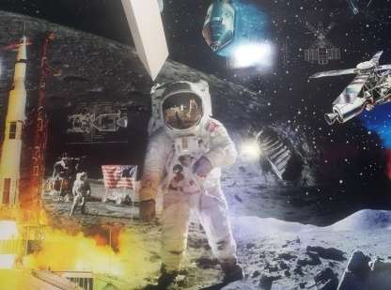
Day 02 –Houston – NASA Space Center + City Tour
After breakfast, visit Mission Control, Rocket Park, Independence Plaza, and the astronaut training facility. See popular landmarks around Houston, stopping briefly for photos during a sightseeing tour. With a map and instructions, enjoy the flexibility to explore the space center on your own time, without the stress of rushing. (Meals: B)

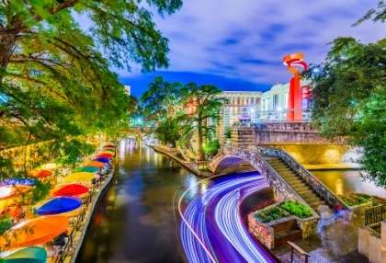
Day 03 – Houston – San Antonio
After breakfast take a plane to San Antonio, a major city in south-central Texas with a rich colonial heritage. The Alamo, an 18th-century Spanish mission preserved as a museum, marks an infamous 1836 battle for Texan independence from Mexico. Following the San Antonio River, the miles-long River Walk is a landmark pedestrian promenade lined with cafes and shops. HemisFair Park’s 750-ft. Tower of the Americas overlooks the city. Transfer to your hotel upon arrival. (Meals: B)

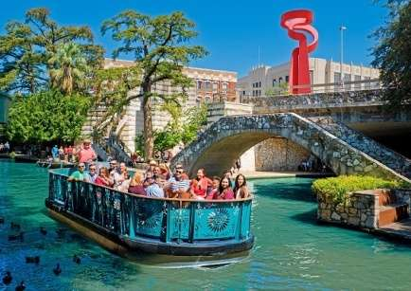
Day 04 –San Antonio Full Day City Tour
Grand Historic City Tour Included details the history, architecture, and confluence of cultures that make San Antonio unique. With exciting narratives and sound effects about historical sites and significant events, this experience covers over 60 points of interest. You will get a grand overview of the Downtown Reach, Museum Reach, and Mission Reach of San Antonio (Meals: B)

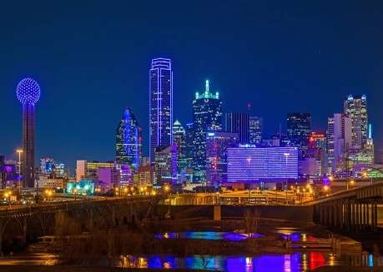
Day 05-San Antonio – Dallas
After breakfast, fly to Dallas, a modern metropolis in north Texas, is a commercial and cultural hub of the region. Downtown’s Sixth Floor Museum at Dealey Plaza commemorates the site of President John F. Kennedy’s assassination in 1963. In the Arts District, the Dallas Museum of Art and the Crow Collection of Asian Art cover thousands of years of art. The sleek Nasher Sculpture Center showcases contemporary sculpture. Transfer to your hotel upon arrival.(Meals: B)

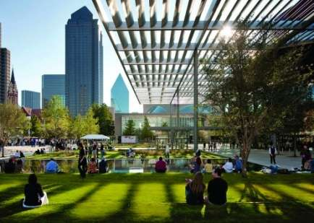
Day 06-Dallas City Tour + JFK
Visit top Dallas highlights on a tour that explores local history, colorful neighborhoods, and the tragic story of President John F. Kennedy's assassination. You'll tick off a long list of highlights, then follow the paths of the Kennedys and John Harvey Oswald, the man accused of killing the president. (Meals: B)

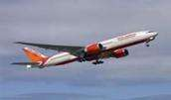
Day 07-Departure from Dallas
After breakfast, we will depart for the airport to board your flight for the next
destination. (Meals: B)

PACKAGE COST & DETAILS
Category | 2 - 5 PAX (USD)
 | Double | Triple/CWB | Single | Child No Bed | Quad
Moderate | 1319 | 1259 | 1819 | 829 | 1189
Deluxe | 1649 | 1589 | 2479 | 879 | 1519

Inclusions:  - Hotel Accommodations  - Breakfast  - Airport- Hotel-Airport Transfers  - City Tours: HOU, SAT, DFW  - Entrance Tickets with transfers: NASA Space Center  - All tours &transfers on SIC  - All Taxes | Exclusions:  - International & Domestic Airfare  - Meet & Greet at airport  - Any Destination Fees/Resort fees at any hotel  - Tips to guides & drivers  - Porterage, Laundry bills & other incidental charges  - For SIC tours – Hotel pick & drop not guaranteed. Client will have to arrange the transfer on its own for any SIC tours.  - Anything not mentioned in inclusions section
Optional cost per person:
- Sea World San Antonio Admission = USD 99.00 per person
- Sea Life Dallas = USD 49.00 per person

HOTELS WILL BE AS BELOW OR SIMILAR:
City | Nts. | Moderate Hotels | Deluxe Hotels
HOU | 2 | Hotel Best Western / Comfort Suites | Hotel Embassy Suites / Residence Inn
SAT | 2 | Hotel Holiday Inn / Best Western | Hotel Residence Inn San Antonio / Doubletree San Antonio
DFW | 2 | Hotel Comfort Inn / Holiday Inn Express | Hotel Hilton Garden Inn /Springhill Suites

BASIC INFORMATION:
Hotels | Transfer/Sightseeing’s | Meal
Check in: 4pm / Check out: 11am | 2-5Pax – SIC basis | Breakfast: As provided by Hotel.
Breakfast time: 6:30 Am to 9:30 Am
Incidental Charges Must be paid by clients

TERMS & CONDITIONS:
- All rates are based on minimum 2Pax traveling together at all tours.
- Surcharges apply for any trade fair/special event/weekend in LAS or any other event in city.
- Child age à 2-9 years. Above 9 years is considered as an adult.
- All rates and availability are subject to change at the time of booking.
- Some events are seasonal like Maid of the Mist, Cave of the Winds, Beast ride, Yosemite Park, Lake Tahoe etc. (Will be closed for winter)
- Optional Meals do not include transfers; the meal will be delivered to your hotel if the restaurant is not within walking distance.
- SIC Tour / Transfer pick-up depends on hotel location, if hotel is outside of pick-up zone, clients will have to make own arrangements.
- We reserve the right to use alternative accommodation, sightseeing tours and transfer of equal or higher standard.
- No refunds either in part or full will be made for any unused services in above package like ground transportation, meals, accommodation, sightseeing tours.
- We are not responsible for any missed breakfast due to flight timings.
- No Intercity surface transfers are included unless specified in the package.
- We are not responsible for any baggage charges by any airlines for the clients.
- Payment for the tour must be made as per the invoice, payment terms & conditions.
- YELLOWSTONE is open from May 01 – November 01, 2016


