7 DAYS – BEST OF BRAZIL

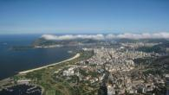
Day 01- Arrival Rio de Janeiro
Welcome to South America’s largest and most populous country. Rio de Janeiro is the second largest city in Brazil, on the South Atlantic coast. Rio is famous for its breathtaking landscape, its laidback beach culture, and its annual carnival. On arrival, transfer to your hotel.

Day 02-Rio City Tour - Corcovado Mountain - Christ the Redeemer
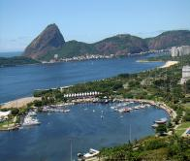
After breakfast, enjoy a full day city tour of Rio. Ascend on Corcovado Mountain by train to visit one of the world’s most famous landmarks, the gigantic statue of Christ, the Redeemer. Then, proceed to Cascatinha, Tijuca Forest, to the top of Corcovado Mountain. Cidade Maravilhosa, "the marvelous city" as it is known to its residents and the rest of Brazil, is also the most beautiful city in the world. As a tropical resort, Rio offers miles of golden beaches, including, Ipanema and Copacabana, two of the most famous stretches of sand in the world. The tour continues with the visit to Metropolitan Cathedral, samba stadium and view of architectonic monuments of Rio. Overnight in Rio.(Meals: B)

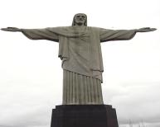
Day 03- Guanabara Bay& Sugar Loaf Mountain
We will take a boat tour of Guanabara Bay, viewing the incredible “Wonder City” from its most famous bay. Based on water volume, Guanabara Bay is the largest bay in the world, and has several islands such as the Governor's Island and Snakes Island. To the west lies Rio de Janeiro, and facing east, the municipal district of Niteroi. Various sights and landmarks such as the neighborhoods of Botafogo, Flamengo, Urca, Sugar Loaf Mountain, Fort Sao Joao, Flagstone Island, Santa Cruz Fortress, Rio-Niteroi Bridge and more will be seen as we depart from the Marina da Gloria. Overnight in Rio.(Meals: B)

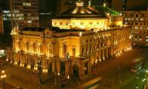
Day 04- Rio de Janeiro - Sao Paulo
Fly to Sao Paulo, and on arrival transfer to your hotel. Take a city tour of São Paulo, the world's second largest city & South America's industrial powerhouse!The city of São Paulo is full of surprises. It is the largest German manufacturing city in the world, and contains great architecture, such as this masterpiece by Oscar Niemeyer, architect of the capital, Brasilia. (Meals: B)

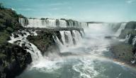
Day 05 - Sao Paulo - Iguassu Falls Brazil
Today after breakfast at the hotel, fly to the natural wonder known as the Iguassu Falls, located on the border of Brazil, Argentina and Paraguay. Upon arrival, check-in at the hotel. Day at leisure. (Meals: B)



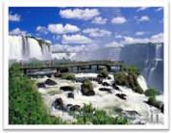
Day 06 - Iguassu Falls
Today after breakfast, we proceed to enjoy the Iguassu Falls National Park, touring the Brazilian side of the Falls. You will walk with the guide, descending a walkway, contemplating the lovely waterfalls in all of nature's exuberance, with panoramic views of both sides - Brazilian and Argentinean. Reach the highest elevation, then descend into the Brazilian side lookout, which provides magnificent photo opportunities and views. Overnight in Iguassu. (Meals: B)

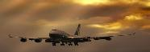
Day 07-Departure
Transfer to the airport to board the flight for your next destination.(Meals: B)

OPTIONAL TOUR
2 DAYS –MANAUS AND AMAZON RAINFOREST, BRAZIL

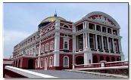
Day 07- Arrival in Manaus
Arrive in Manaus. Located in the middle of the Amazon Rainforest, Manaus is the capital of Brazil’s largest state, Amazonas, an incongruous pocket of urbanity in the middle of the jungle, a major port for ocean vessels that’s 1500km from the ocean. Overnight in Manaus. (Meals: B)

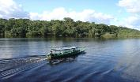
Day 08- Amazon Rainforest
This morning enjoy a Meeting of the Waters tour, where the Rio Negro&Amazon run side by side. Afterward go for a nature hike through the jungle, then have lunch featuring typical Amazonian dishes. Visit to the home of local Amazonian residents with an opportunity for piranha fishing. (Meals: B)

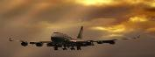
Day 09 - Departure
Transfer to the airport to board the flight for your next destination.(Meals: B)

PACKAGE COST & DETAILS
Category | 2 - 5 PAX (USD)
 | DBL | TRL/CWB | SGL | CNB | Quad
Deluxe | 2529 | 2469 | 3189 | 1869 | 2399

Inclusions:  - Deluxe Hotel Accommodations  - Breakfast  - Airport- Hotel-Airport Transfers  - City Tour on SIC: Rio De Janeiro, Sao Paulo  - Entrance Tickets with transfers : Corcovado, Sugar Loaf, Guanabara Bay Boat tour, Iguassu Falls Boat ride  - All tours & transfers on SIC  - All Taxes | Exclusions:  - International & Domestic Airfare  - Intercity travel by Flight / Bus / Train  - Meet & Greet at airport  - Any Destination Fees/Resort fees at any hotel  - Tips to guides & drivers  - Porterage, Laundry bills & other incidental charges  - For SIC tours – Hotel pick & drop not guaranteed. Client will have to arrange the transfer on its own for any SIC tours.  - Anything not mentioned in inclusions section
Optional Extension Tour:
2 day’s Manaus and Amazon Rainforest, Brazil = USD 895.00 per person on DBL

HOTELS WILL BE AS BELOW OR SIMILAR:
City | Nts. | Deluxe Hotels
Rio | 03 | Hotel Ocean Copacabana / Copu Sul or similar
Sao Paulo | 01 | Hotel Holiday Inn / Comfort Suites or similar
Iguassu | 02 | Hotel Recanto or similar

BASIC INFORMATION:
Hotels | Transfer/Sightseeing’s | Meal
Check in time: 4pm / Check out time: 11am | 2-5 Pax – SIC basis | Breakfast: As provided by Hotel.
Breakfast time: 6:30 Am to 9:30 Am
Incidental Charges Must be paid by clients

TERMS & CONDITIONS:
- All rates are based on minimum 2Pax traveling together at all tours.
- Surcharges apply for any trade fair/special event/weekend in LAS or any other event in city.
- Child age à 2-9 years. Above 9 years is considered as an adult.
- All rates and availability are subject to change at the time of booking.
- Some events are seasonal like Maid of the Mist, Cave of the Winds, Beast ride, Yosemite Park, Lake Tahoe etc. (Will be closed for winter)
- Optional Meals do not include transfers; the meal will be delivered to your hotel if the restaurant is not within walking distance.
- SIC Tour / Transfer pick-up depends on hotel location, if hotel is outside of pick-up zone, clients will have to make own arrangements.
- We reserve the right to use alternative accommodation, sightseeing tours and transfer of equal or higher standard.
- No refunds either in part or full will be made for any unused services in above package like ground transportation, meals, accommodation, sightseeing tours.
- We are not responsible for any missed breakfast due to flight timings.
- No Intercity surface transfers are included unless specified in the package.
- We are not responsible for any baggage charges by any airlines for the clients.
- Payment for the tour must be made as per the invoice, payment terms & conditions.

