7 DAYS–BEST OF SEATTLE & PORTLAND

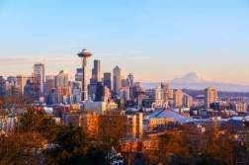
Day 01-Seattle
Welcome a city on Puget Sound in the Pacific Northwest, is surrounded by water, mountains and evergreen forests, and contains thousands of acres of parkland. Washington State’s largest city, it’s home to a large tech industry, with Microsoft and Amazon headquartered in its metropolitan area. The futuristic Space Needle, a 1962 World’s Fair legacy, is its most iconic landmark. Transfer to your hotel upon arrival.

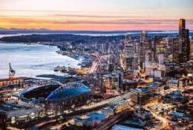
Day 02 –Seattle City Tour + Space Needle
Knowledgeable guide presents Seattle’s neighborhoods and attractions. See the iconic Space Needle (admission included) with stellar views of the Olympic and Cascade mountain ranges, including majestic Mt Rainier. There’s Pike Place Market and the Elliott Bay waterfront, plus Pioneer Square. (Meals: B)

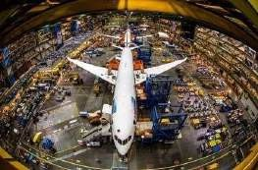
Day 03 – Seattle – Boeing Factory Tour
See how airplanes are built on this small-group trip to the Boeing factory near Seattle. Visit the massive Boeing assembly plant, the world’s largest building by volume, and see a variety of different planes in production. Then explore the interactive exhibits and displays in the Aviation Center Gallery and visit the educational Future of Flight Aviation Center museum. (Meals: B)

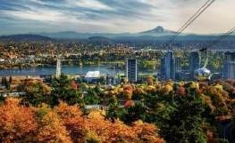
Day 04 –Seattle – Portland
Welcome to Portland, Oregon’s largest city, sits on the Columbia and Willamette rivers, in the shadow of snow-capped Mount Hood. It’s known for its parks, bridges and bicycle paths, as well as for its eco-friendliness and its microbreweries and coffeehouses. Transfer to your hotel upon arrival. (Meals: B)

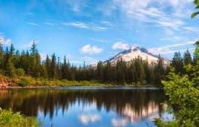
Day 05-Mt Hood Day Trip
Immerse yourself in the beauty of Columbia River Gorge on this full-day trip from Portland to Mount Hood! With your small group, take a guided tour of such iconic Oregon destinations as Multnomah Falls and the famous Timberline Lodge, and enjoy lunch in the charming city of Hood River..(Meals: B)

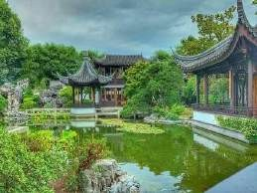
Day 06-Portland City Tour
Explore Portland on a city sightseeing tour that travels from downtown Portland to the Pearl District to Nob Hill. Take a tour of the Pittock Mansion and see Lan Su Chinese Garden, collaboration between Portland and sister-city Suzhou, China. Stroll through the International Rose Test Garden, located in Washington Park and boasting more than 7,000 rose plants with 550 varieties represented. Learn about the history and culture of Portland, which has been growing rapidly in recent years. (Meals: B)

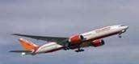
Day 07-Departure from Portland

After breakfast, we will depart for the airport to board your flight for the next destination. (Meals: B)

PACKAGE COST & DETAILS

Category | 2 - 5 PAX (USD)
 | Double | Triple/CWB | Single | Child No bed | Quad
Moderate | 1539 | 1479 | 2039 | 1049 | 1409
Deluxe | 1929 | 1859 | 2749 | 1079 | 1789

Inclusions:  - Hotel Accommodations  - Breakfast  - Airport- Hotel-Airport Transfers  - City Tours: PDX, SEA  - Entrance Tickets with transfers: Space Needle, Boeing factory  - Mt Hood Day Trip from Portland to Multnomah Falls and Hood River  - All tours &transfers on SIC  - All Taxes | Exclusions:  - International & Domestic Airfare  - Meet & Greet at airport  - Any Destination Fees/Resort fees at any hotel  - Tips to guides & drivers  - Porterage, Laundry bills & other incidental charges  - For SIC tours – Hotel pick & drop not guaranteed. Client will have to arrange the transfer on its own for any SIC tours.  - Anything not mentioned in inclusions section
 | Optional cost per person:

HOTELS WILL BE AS BELOW OR SIMILAR:

City | Nts. | Moderate Hotels | Deluxe Hotels
SEA | 3 | Ramada Kent / Hampton Inn | Courtyard Marriott / Four Point Sheraton
PDX | 3 | Comfort Inn / Quality Inn | Doubletree by Hilton / Residence Inn by Marriott

BASIC INFORMATION:

Hotels | Transfer/Sightseeing’s | Meal
Check in: 4pm / Check out: 11am | 2-5Pax – SIC basis | Breakfast: As provided by Hotel.
Breakfast time: 6:30 Am to 9:30 Am
Incidental Charges Must be paid by clients

TERMS & CONDITIONS:

- All rates are based on minimum 2Pax traveling together at all tours.
- Surcharges apply for any trade fair/special event/weekend in LAS or any other event in city.
- Child age ? 2-9 years. Above 9 years is considered as an adult.
- All rates and availability are subject to change at the time of booking.
- Some events are seasonal like Maid of the Mist, Cave of the Winds, Beast ride, Yosemite Park, Lake Tahoe etc. (Will be closed for winter)
- Optional Meals do not include transfers; the meal will be delivered to your hotel if the restaurant is not within walking distance.
- SIC Tour / Transfer pick-up depends on hotel location, if hotel is outside of pick-up zone, clients will have to make own arrangements.
- We reserve the right to use alternative accommodation, sightseeing tours and transfer of equal or higher standard.
- No refunds either in part or full will be made for any unused services in above package like ground transportation, meals, accommodation, sightseeing tours.
- We are not responsible for any missed breakfast due to flight timings.
- No Intercity surface transfers are included unless specified in the package.
- We are not responsible for any baggage charges by any airlines for the clients.
- Payment for the tour must be made as per the invoice, payment terms & conditions.
- YELLOWSTONE is open from May 01 – November 01, 2016

