7 DAYS –CANADIAN ROCKIES (Van Tour)
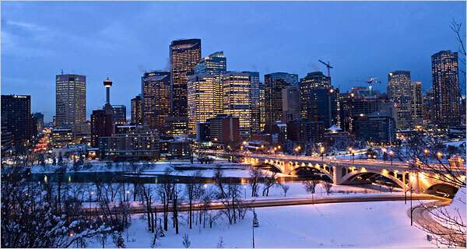

Day 01-Calgary - Banff
Welcome to Calgary. Experience the authentic and vibrant community, modern amenities and beautiful surroundings of the Town of Banff. Upon arrival, transfer to Banff, then proceed to the hotel and check-in.

Day 02 - Banff
Today after breakfast, we will set out to explore the Sulphur Mountains. The mountain were named in 1916 for the hot springs on its lower slopes. The springs have been developed into swimming and hot pools. We will then take a Gondola ride in order to explore Sculpture Mountain. Later in the afternoon, we will be heading towards the Lake Louise known for its scenic beauty. (Meals: B)

Day 03- Banff -Ice fields - Jasper
Today after breakfast, we will leave Banff for Jasper by road. It has to be one of the most beautiful drives in the world, Banff to Jasper via the Ice fields Parkway. Later proceed for Jasper, check-in to the hotel (Meals: B)

Day 04 - Jasper - Kamloops
Today after breakfast, we will leave Jasper for Kamloops by road. Upon arrival, we will go for city tour of Kamloops. (Meals: B)

Day 05 - Vancouver- Capilano Suspension Bridge
After breakfast, we will heading for the Capilano Suspension Bridge, a simple suspension bridge crossing the Capilano River in the District of North Vancouver, British Columbia. Later, we will do a half day sightseeing tour of Vancouver, which includes Stanley Park followed by the English Bay. (Meals: B)

Day 06 - Vancouver - Whistler
Today, we will be heading to the Whistler to ride Whistler Village Gondola which is located at the base of Whistler Mountain in Whistler Village; from here you will enjoy breathtaking view of PEAK 2 PEAK between Whistler and Blackcomb Mountains. In the evening, we will return to our hotel in Vancouver and overnight stay. (Meals: B)

Day 07- Vancouver - Fly Out
Today after breakfast, we will depart to your next destination. (Meals: B)
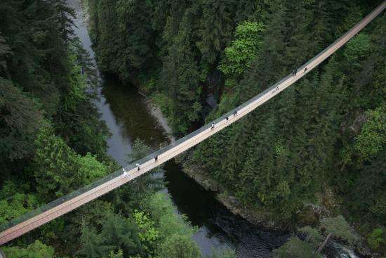
Tour ends with sweet memories.

PACKAGE COST & DETAILS
Category | 6-9 PAX (USD) / per person |  |  |  |  | 10-13 PAX (USD) / per person
 | Double | Triple/CWB | Single | CNB | Quad | Double | Triple/CWB | Single | CNB | Quad
Deluxe | 2969 | 2909 | 3729 | 2209 | 2839 | 2529 | 2469 | 3289 | 1769 | 2399

Inclusions:  - Deluxe Hotel Accommodations  - Breakfast  - Airport Transfers as mentioned  - City Tour: Vancouver  - Surface Transfers: CAL>BAN>JAS>KAM>VAN  - Entrance Tickets of: Banff Gondola ride, Peak to peak Gondola, Icefield Explorer ride, Capilano Suspension Bridge  - All Taxes  - All transfers & sight seen on PVT (Sprinter Van) | Exclusions:  - International & Domestic Airfare  - Meet & Greet at airport  - Supplement cost applicable for Weekends  - Tips to guides & drivers  - Porterage, Laundry bills & other incidental charges  - Anything that is not mentioned in the inclusions part.  - Any Destination Fees/Resort fees at any hotel

HOTELS:
City | Nts. | Deluxe Hotels OR SIMILAR
BAN | 02 | Hotel Holiday Inn Cannmore / Banff Caribou
JAS | 01 | Hotel Chateau Jasper / Holiday Inn Hinton
KAM | 01 | Hotel Four Point Sheraton / Fairfield by Marriott
VAN | 02 | Hotel Sandman / Sheraton Guildford / Holiday Inn

BASIC INFORMATION:
Hotels | Transfer | Meal
Check in time: 4pm / Check out time: 11am | All on PVT basis (Sprinter Van) | Breakfast: As provided by Hotel.
Breakfast time: 6:30 Am to 9:30 Am |  | Lunch: On Own
Incidental Charges Must be paid by clients |  | Dinner: On Own

GENERAL TERMS & CONDITIONS:
- Tours will be conducted in a Van with driver cum guide depending on the number of passengers confirmed.
- Child age 2-9 years. Above 9 years is considered as an adult.
- We reserve the right to use alternative accommodation, sightseeing tours and transfer of equal or higher standards.
- No refunds either in part or full will be made for any unused services in above package like ground transportation, meals, accommodation, sightseeing tours.
- The Incidental charges are not included: for instance: Porterage, tips, laundry, telephone calls, alcohol/non-alcoholic beverages.
- Early check-In is not guaranteed. Every effort will be made for passengers coming in early but this is at the hotel’s discretion & availability.
- Passengers requiring Wheelchair assistance will have to make their own arrangements.
- Please note that some hotels require guests to give their Credit card/cash towards incidentals. No charges are levied unless guests use services not included in the package.
- Please note for dinners in Niagara Falls, Orlando & Las Vegas, and the restaurant will be walking distance from the Hotel and no transfers will be provided for the same.
- Final working itinerary and vouchers will be sent by email 07 days prior to departure date.



