7 DAYS –EASTERN EXPLORER (Van Tour)

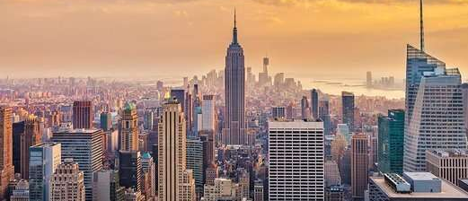

Day 01 - Arrive in New York- Manhattan by Night tour
Welcome to the "Big Apple," the "City That Never Sleeps"—New York is a city of superlatives: America's biggest; its most exciting; its business and cultural capitals; the nation's trendsetter. For more than a century, it has been one of the world's major centers of commerce and finance. Upon arrival at the airport, transfer to the hotel (as group). After checking into your hotel join us for an Illuminated tour of Manhattan - Experience New York, the ‘city that never sleeps,’ magically lit up after dark. Drive past illuminated landmarks like the Empire State Building, Times Square, Rockefeller Center, and the neighborhoods of SoHo and Chinatown. Dinner in the evening and then transfer back to the Hotel.

Day 02 - New York City Tour
After breakfast, we proceed for a City tour of New York. The sightseeing will include USA’s famous landmark, “Statue of Liberty.” We will take a ferry ride to Liberty Island for a spectacular view of the New York City Skyline. Next we experience the view of a lifetime of the One World Observatory. Later in the day we will see Rockefeller Center, Wall Street, Ground Zero and Central Park, Times Square, United Nations and Trump Tower. (Meals: B)

Day 03- New York -Philadelphia - Washington
Today, we depart to Washington DC by road; (approx. 5 hours). It is the capital city of the United States of America and Guide to the Historic Neighborhoods and Monuments. Stop in Philadelphia en-route for an orientation tour, then continue on to Washington DC. Upon arrival, you will check in to the hotel (Meals: B)

Day 04 - Washington-Luray Caverns
After breakfast, check out of the hotel and proceed to the town of Luray, VA, home of the Luray Caverns. Perhaps the most famous attraction in the Luray Caverns is The Great Stalactite Organ, a giant mechanized instrument that uses naturally formed stalagmites as its pipes. Later, explore the capital city of US. Visit the White House, Lincoln Memorial, Supreme Court, the Capitol Building, the Smithsonian Air and Space museum, Museum of Natural history, Union Station, World War II Memorial Building, Pentagon building and Washington monument. (Meals: B)

Day 05 -Washington DC - Harrisburg- USA side Niagara Falls
After breakfast, check out of the hotel and proceed to Harrisburg for the Hershey’s Chocolate World. Later, proceed to Niagara by road (approx. 5 hours). Reach Niagara to view the famous falls, which form one of the natural wonders of the World. Check in to your hotel, freshen up, visit the shops for buying souvenirs &in the evening get back to hotel. You can also visit the illumination on the falls on your own tonight. (Meals: B)

Day 06- Niagara Falls + Maid of Mist + Cave of Winds
There is nowhere else in the world where you can ride the world famous Maid of the Mist Boat Tour, walk within feet of the Falls at the Cave of the Winds. (Meals: B)

Day 07 -Departure
After breakfast, spend some time at leisure. Take some time out for additional shopping, proceed to the airport as group departure to board the flight for your next destination. (Meals: B)

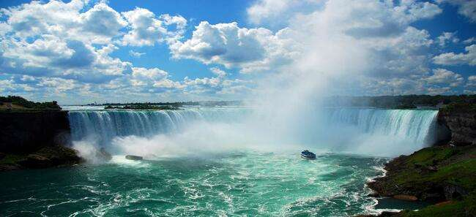
Tour ends with sweet memories.

PACKAGE COST & DETAILS
Category | 6-9 PAX (USD) / per person |  |  |  |  | 10-13 PAX (USD) / per person
 | Double | Triple/CWB | Single | CNB | Quad | Double | Triple/CWB | Single | CNB | Quad
Deluxe | 2199 | 2139 | 2659 | 1739 | 2069 | 1759 | 1699 | 2219 | 1299 | 1629

Inclusions:  - Deluxe Hotel Accommodations  - Breakfast  - Airport Transfers as mentioned  - City Tour: New York, Washington  - Orientation tour: Philadelphia  - Surface Transfers: NYC-WAS-NIA  - Entrance Tickets: Statue of Liberty Cruise, One World Observatory, Luray Caverns, Smithsonian Air & Space Museum, Museum of natural history, Hershey’s chocolate world, Maid of Mist, Cave of Winds  - All Taxes  - All transfers & sight see on PVT basis (Sprinter Van) | Exclusions:  - Any Air Tickets  - Airline Baggage charges  - Anything that is not mentioned in the inclusions part.  - Any Destination Fees/Resort fees at any hotel  Optional Costs:  - Niagara Helicopter = USD 149 per person  - Dinner= USD 35.00 per person

HOTELS:
City | Nts. | Deluxe Hotels OR SIMILAR
NYC | 02 | Hotel Wyndham Garden Totowa / APA Woodbridge / Embassy Suites NJ
WAS | 02 | Hotel Doubletree Dulles / Wyndham Garden
NIA | 02 | Hotel Wyndham / Hyatt Place / Holiday Inn / Wingate Inn

BASIC INFORMATION:
Hotels | Transfer | Meal
Check in time: 4pm / Check out time: 11am | All on PVT basis (Sprinter Van) | Breakfast: As provided by Hotel.
Breakfast time: 6:30 Am to 9:30 Am |  | Lunch: On Own
Incidental Charges and Resort fee. Must be paid by clients |  | Dinner: On own

GENERAL TERMS & CONDITIONS:
- Tours will be conducted in a Van with driver cum guide depending on the number of passengers confirmed.
- Child age 2-9 years. Above 9 years is considered as an adult.
- We reserve the right to use alternative accommodation, sightseeing tours and transfer of equal or higher standards.
- No refunds either in part or full will be made for any unused services in above package like ground transportation, meals, accommodation, sightseeing tours.
- The Incidental charges are not included: for instance: Porterage, tips, laundry, telephone calls, alcohol/non-alcoholic beverages.
- Early check-In is not guaranteed. Every effort will be made for passengers coming in early but this is at the hotel’s discretion & availability.
- Passengers requiring Wheelchair assistance will have to make their own arrangements.
- Please note that some hotels require guests to give their Credit card/cash towards incidentals. No charges are levied unless guests use services not included in the package.
- Please note for dinners in Niagara Falls, Orlando &Las Vegas, and the restaurant will be walking distance from the Hotel and no transfers will be provided for the same.
- Final working itinerary and vouchers will be sent by email 07 days prior to departure date.

