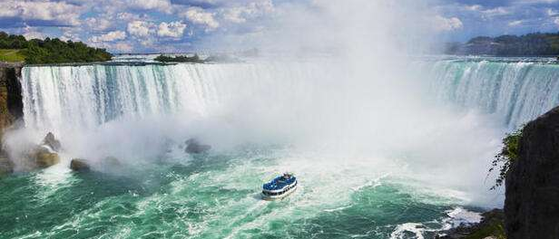
7 DAYS – ELEGANT EAST CANADA (Van Tour)
Day 01 –Arrive in Toronto
Welcome to Toronto! A fabulous waterfront city lying on the north shore of Lake Ontario, Toronto is Canada’s largest and most cosmopolitan city. Evening proceed for a City Tour of Toronto, where you will explore the Hockey Hall of Fame, CN Tower, Rogers Centre, Air Canada Centre, Olympic Spirit, Toronto's Harborfront, St. Lawrence Market, the Entertainment District, Casa Loma, the Royal Ontario Museum, Bata Shoe Museum, and Eaton Centre.

Day 02 - Toronto - Niagara
Arrive in Niagara. After breakfast, today you will proceed towards Canada’s greatest Natural Wonder, Niagara Falls. You will visit Horseshoe Falls, Table Rock, floral clock, Clifton Hill and Niagara on the Lake. You will ride the famous “Maid of the Mist,” which takes us close to the thundering Falls and around the American Falls (seasonal) Later Enjoy the Journey Behind the falls. Later, we will proceed back to Toronto. (Meals: B)

Day 03 - Niagara - Kingston - Ottawa
After breakfast today, we will be leaving for Kingston. On reaching Kingston, we will do the 1000 Island Cruise. Later, proceed for Montreal. (Meals: B)

Day 04 - Ottawa - City Tour - Montreal
After breakfast, proceed for a guided city tour, including the Parliament Building, Supreme Court of Canada, National Arts Center, Rideau Canal, Ottawa City Hall, Rockcliffe Lookout, Ows Lake, Ornamental Gardens, Chinatown & Little Italy, and Farmer’s Market. Later proceed to Montreal. (Meals: B)

Day 05 - Montreal - City Tour
After breakfast, proceed for an exciting city tour of Montreal. Visit Old Montreal, Notre-Dame Basilica, Olympia Park, Mount Royal Park, St. Joseph's Oratory, Montreal Harbor, Chinatown, Place Ville Marie, City Hall, Bell Centre, Downtown Montreal and much more. (Meals: B)

Day 06 - Montreal -Quebec City Tour
After breakfast, proceed for a day tour to Quebec City. We will bring you through all the historical treasures of Quebec such as: Place Royale, Plains of Abraham, Parliament Building, Montmorency Falls, Ile D'Orleans, Place D'Armes and many more. (Meals: B)

Day 07 - Montreal
After breakfast, we will fly back to the home town. (Meals: B)
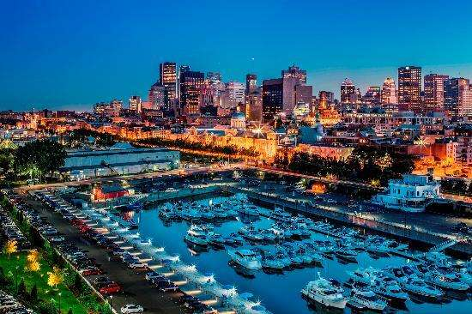

Tour ends with sweet memories.

PACKAGE COST & DETAILS
Category | 6-9 PAX (USD) / per person |  |  |  |  | 10-13 PAX (USD) / per person
 | Double | Triple/CWB | Single | CNB | Quad | Double | Triple/CWB | Single | CNB | Quad
Deluxe | 2529 | 2469 | 3129 | 1939 | 2399 | 2089 | 2029 | 2689 | 1499 | 1959

Inclusions:  - Deluxe Hotel Accommodations  - Breakfast  - Airport- Hotel-Airport Transfers  - Guided City Tour: Toronto, Montreal, Quebec City, Ottawa  - Surface Transfers: TOR >NIA >OTT>MON  - Entrance Tickets : Maid of the Mist, Journey behind the falls, CN Tower, 1000 Islands Cruise, Olympic Park  - All Taxes  - All transfers & sight seen on PVT (Sprinter Van) | Exclusions:  - International Airfare  - Meet & Greet at airport  - Tips to guides & drivers  - Porterage, Laundry bills & other incidental charges  - Anything not mentioned in inclusions section  - Any Destination Fees/Resort fees at any hotel

HOTELS:
City | Nts. | Deluxe Hotels OR SIMILAR
TOR | 02 | Hotel Four Point Sheraton Mississauga / Edward Hotel
OTT | 01 | Hotel Four Point Sheraton / Courtyard Marriott / Holiday Inn
MON | 03 | Hotel Fairfield by Marriott / Courtyard Marriott / Doubletree

BASIC INFORMATION:
Hotels | Transfer | Meal
Check in time: 4pm / Check out time: 11am | All on PVT basis (Sprinter Van) | Breakfast: As provided by Hotel.
Breakfast time: 6:30 Am to 9:30 Am |  | Lunch: On Own
Incidental Charges Must be paid by clients |  | Dinner: On Own

GENERAL TERMS & CONDITIONS:
- Tours will be conducted in a Van with driver cum guide depending on the number of passengers confirmed.
- Child age 2-9 years. Above 9 years is considered as an adult.
- We reserve the right to use alternative accommodation, sightseeing tours and transfer of equal or higher standards.
- No refunds either in part or full will be made for any unused services in above package like ground transportation, meals, accommodation, sightseeing tours.
- The Incidental charges are not included: for instance: Porterage, tips, laundry, telephone calls, alcohol/non-alcoholic beverages.
- Early check-In is not guaranteed. Every effort will be made for passengers coming in early but this is at the hotel’s discretion & availability.
- Passengers requiring Wheelchair assistance will have to make their own arrangements.
- Please note that some hotels require guests to give their Credit card/cash towards incidentals. No charges are levied unless guests use services not included in the package.
- Please note for dinners in Niagara Falls, Orlando & Las Vegas, and the restaurant will be walking distance from the Hotel and no transfers will be provided for the same.
- Final working itinerary and vouchers will be sent by email 07 days prior to departure date.

