7 DAYS- ELEGANT EAST COAST USA

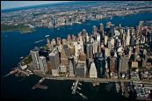
Day 01- Arrive in New York
Welcome to the "Big Apple," the "City That Never Sleeps"—New York is a city of superlatives: America's biggest; its most exciting; its business and cultural capitals; the nation's trendsetter. For more than a century, it has been one of the world's major centers of commerce and finance. Upon arrival at the airport, you will be transferred to the hotel.

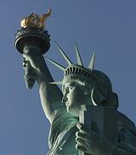
Day 02 - New York City Tour
After breakfast, proceed for a City Tour of New York. The sightseeing will include USA’s famous landmark, “Statue of Liberty.” We will take a ferry ride to Liberty Island for a spectacular view of the New York City Skyline. Next we experience the view of a lifetime from the 86th floor of the Empire State Building. Later in the day, we will see Rockefeller Center, Wall Street, Ground Zero and Central Park, Times Square, United Nations and Trump Tower. (Meals: B)

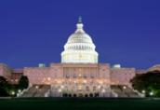
Day 03- New York - Washington D.C.
Today we proceed by plane/train to Washington D.C., capital of the United States of America and Guide to the Historic Neighborhoods and Monuments. Other than the federal government, tourism is DC's biggest industry. The city attracts almost twenty million visitors each year. (Meals: B)

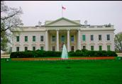
Day 04 - Washington City Tour
After Breakfast, you will explore the capital city of US. Visit the White House, Lincoln Memorial, Supreme Court, the Capitol Building, the Smithsonian Air and Space Museum, Union Station, World War II Memorial Building, Pentagon building and Washington monument. (Meals: B)

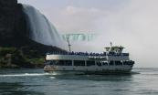
Day 05- Washington - Buffalo- USA side Niagara Falls
Today, we proceed by plane/train/road to Buffalo, to view the world-famous falls, which form one of the natural Wonders of the World. (Meals: B)

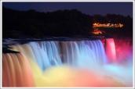
Day 06 - Visit the Famous Niagara Falls
Today, we will board the famous boat “Maid of the Mist,” which takes us close to the thundering falls and around the American and Horseshoe Falls (seasonal). Return to the hotel to freshen up after your damp ride. You can also visit the falls on own at night to see them lit up beautifully. (Meals: B)

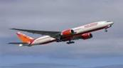
Day 07- Departure from Niagara
Today, we finish our trip and get ready to fly back home or to the next
Destination. (Meals: B)

PACKAGE COST & DETAILS
Category | 2 - 5 PAX (USD)
 | Double | Triple/CWB | Single | Child No Bed | Quad
Moderate | 1429 | 1369 | 2059 | 799 | 1299
Deluxe | 1649 | 1589 | 2479 | 829 | 1519

Inclusions:  - Hotel Accommodations  - Breakfast  - Airport- Hotel-Airport Transfers  - City Tour on SIC: New York, Washington D.C  - Entrance Tickets with transfers: Statue of Liberty, Empire State Building  - Entrance Tickets without transfers: Maid of the Mist  - All tours & transfers on SIC  - All Taxes |  |  | Exclusions:  - International & Domestic Airfare  - Intercity travel by Flight / Bus / Train  - Supplement cost applicable for Weekend in NIA  - Any Destination Fees/Resort fees at any hotel  - Meet & Greet at airport  - Tips to guides & drivers  - Porterage, Laundry bills & other incidental charges  - For SIC tours – Hotel pick & drop not guaranteed. Client will have to arrange the transfer on its own for any SIC tours.  - Anything not mentioned in inclusions section
Optional cost per person:
- 2-5pax= Return PVT Airport trns Per Dest=
USD 35.00 per person
City | Nts. | Moderate Hotels or similar | Deluxe Hotels or similar
NYC | 02 | Hotel Fairfield Inn Manhattan / Holiday Inn | Hotel Doubletree Manhattan / Hilton Manhattan
WAS | 02 | Hotel Comfort Inn / Best Western | Hotel Doubletree Dulles / Wyndham Garden
NIA | 02 | Hotel Quality Inn at Falls / Laquinta Inn | Hotel Hyatt Place / Holiday Inn at Falls

BASIC INFORMATION:
Hotels | Transfer/Sightseeing’s | Meal
Check in: 4pm / Check out: 11am | 2-5Pax – SIC basis | Breakfast: As provided by Hotel.
Breakfast time: 6:30 Am to 9:30 Am
Incidental Charges Must be paid by clients

TERMS & CONDITIONS:
- All rates are based on minimum 2Pax traveling together at all tours.
- Surcharges apply for any trade fair/special event/weekend in LAS or any other event in city.
- Child age à 2-9 years. Above 9 years is considered as an adult.
- All rates and availability are subject to change at the time of booking.
- Some events are seasonal like Maid of the Mist, Cave of the Winds, Beast ride, Yosemite Park, Lake Tahoe etc. (Will be closed for winter)
- Optional Meals do not include transfers; the meal will be delivered to your hotel if the restaurant is not within walking distance.
- SIC Tour / Transfer pick-up depends on hotel location, if hotel is outside of pick-up zone, clients will have to make own arrangements.
- We reserve the right to use alternative accommodation, sightseeing tours and transfer of equal or higher standard.
- No refunds either in part or full will be made for any unused services in above package like ground transportation, meals, accommodation, sightseeing tours.
- We are not responsible for any missed breakfast due to flight timings.
- No Intercity surface transfers are included unless specified in the package.
- We are not responsible for any baggage charges by any airlines for the clients.

- Payment for the tour must be made as per the invoice, payment terms & conditions.

