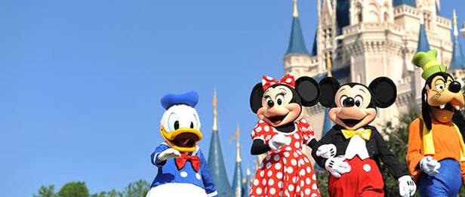
7 DAYS- FUN FILLED FLORIDA(VAN TOUR)

Day 01-Orlando

Welcome to Orlando. Orlando is the sixth largest city of Florida and is also known to be its largest inland city. The presence of the Disney World theme park has made this city a well-known vacation spot. The city is said to welcome more than 52 million tourists every year. Upon arrival, transfer to your hotel.

Day 02 - Orlando - Walt Disney Magic Kingdom
Today you visit Magic Kingdom, which covers 107 acres and was opened on October 1, 1971. It's been dubbed "The Most Magical Place on Earth!" and is home to seven themed lands, and dozens of attractions that appeal to all ages. It is the place where storybook fantasy is everyday reality, and Disney classics are brought to life. From the moment you step onto Main Street USA, you are transported to a place where the cares of the outside world seem to magically melt away. (Meals: B)

Day 03 - Orlando - Epcot Center
Begin your day at the Epcot center, where you can touch the future and travel the world with an amazing array of attractions and live performances. This is an area of 260 acres devoted to past achievements and the future of technology. World showcase offers a kind of permanent World Fair, with pavilions devoted to eleven countries. (Meals: B)

Day 04 - Orlando - SeaWorld
Today you will visit the world's largest Marine Park, Sea World. Here, you shall discover many attractions. We dare you to take a one-of-a kind water coaster thrill ride through the mysterious lost city of Atlantis. Soar through danger on a jet copter ride to the Wild Arctic. At Sea World, touch, feed or get face to face with awesome and amazing wild animals, and get in on all the action that draws you back again and again! (Meals: B)

Day 05 - Orlando -Miami
Today you will drive to Miami, Florida. Upon arrival, proceed for a City Tour of Miami, where you will visit Central Station / Bay front Park, Ocean Drive, Lincoln Road, Coconut Grove, Little Havana and much more. It is also well known for its beaches including South Beach, trendy nightlife, the Art Deco district, CalleOcho& Little Havana. Enjoy the beach, or just relax before enjoying a wonderful meal at restaurant. (Meals: B)

Day 06 - Miami - Tampa - Busch Gardens
Today you will transfer to Tampa. Busch Gardens Tampa Bay is the ultimate family adventure park, offering
335 acres of fascinating attractions based on exotic adventures around the world. Overnight in Tampa.
(Meals: B)

Day 7- Departure from Orlando

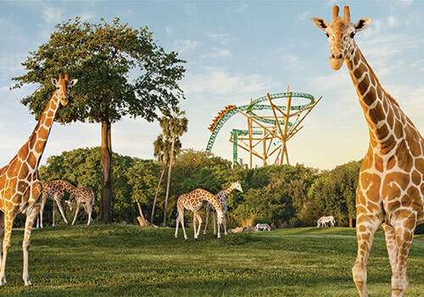
After breakfast, you will transfer from Tampa to Orlando where you will head to the airport to board your flight for the next destination. (Meals: B)

Tour ends with sweet memories.

PACKAGE COST & DETAILS
Category | 6-9 PAX (USD) / per person |  |  |  |  |  | 10-13 PAX (USD) / per person
 | Double | Triple/CWB | Single | CNB | Quad |  | Double | Triple/CWB | Single | CNB | Quad
Deluxe | 2639 | 2579 | 3139 | 2149 | 2509 |  | 2259 | 2189 | 2749 | 1759 | 2129
Inclusions:  - Hotel Accommodations  - Breakfast  - Airport- Hotel-Airport Transfers  - City Tour: Miami  - Surface Transfer: ORL>MIA>TPA>ORL by VAN  - Entrance Tickets with transfers: Sea World, Epcot Center, Magic Kingdom, Busch Gardens  - All Taxes |  |  |  |  |  | Exclusions:  - International Airfare  - VUSA Air Tickets  - baggage charges  - Porterage  - Any Destination Fees/Resort fees at any hotel

HOTELS WILL BE AS BELOW OR SIMILAR:
City | Nts. | Deluxe Hotels
ORL | 04 | Hotel Four Point Sheraton / Courtyard Marriott / Crown Plaza / Delta
MIA | 01 | Hotel Springhill Suites Medical Center / Doubletree
TPA | 01 | Hotel Hyatt Place / Courtyard by Marriott / Embassy Suites

BASIC INFORMATION:
Hotels | Transfer/Sightseeing’s | Meal
Check in: 4pm / Check out: 11am | All on PVT (Sprinter Van) | Breakfast: As provided by Hotel.
Breakfast time: 6:30 Am to 9:30 Am
Incidental Charges Must be paid by clients

GENERAL TERMS & CONDITIONS:
- Tours will be conducted in a Van with driver cum guide depending on the number of passengers confirmed.
- Child age 2-9 years. Above 9 years is considered as an adult.
- We reserve the right to use alternative accommodation, sightseeing tours and transfer of equal or higher standards.
- No refunds either in part or full will be made for any unused services in above package like ground transportation, meals, accommodation, sightseeing tours.
- The Incidental charges are not included: for instance: Porterage, tips, laundry, telephone calls, alcohol/non-alcoholic beverages.
- Early check-In is not guaranteed. Every effort will be made for passengers coming in early but this is at the hotel’s discretion & availability.
- Passengers requiring Wheelchair assistance will have to make their own arrangements.
- Please note that some hotels require guests to give their Credit card/cash towards incidentals. No charges are levied unless guests use services not included in the package.
- Please note for dinners in Niagara Falls, Orlando & Las Vegas, and the restaurant will be walking distance from the Hotel and no transfers will be provided for the same.
- Final working itinerary and vouchers will be sent by email 07 days prior to departure date.

