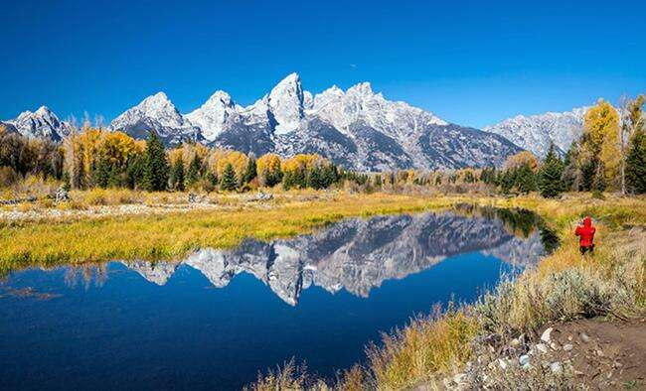
7 DAYS –National Parks Wonders (Van Tour)

Day 01- Salt Lake City + City Tour

Welcome to Salt Lake City, the capital and most populous municipality of the U.S. state of Utah. Upon arrival, check in to the hotel. Later stroll around the landmarks and gardens of Temple Square, admire the historic buildings along Brigham Street, visit Capitol Hill and the Utah State Capital building, and enjoy views over Salt Lake City and the surrounding Rocky Mountains. Upon arrival, check in to the hotel
Day 02 – Salt Lake City – Jackson Hole
Welcome to the West! On the way to Jackson Hole you will visit multiple viewpoints. This trail was the main overland route for a hundreds of thousands of settlers migrating from the East Coast to the Western US. This city takes you back to the spirit of the Old West with a relaxing atmosphere and authentic cowboy entertainments. Upon arrival, check in to the hotel. (Meals: B)

Day 03- Jackson Hole - Grand Teton National Park
Spend a day taking in the spectacular scenery and wildlife of Grand Teton National Park. Travel to the highlights of the park with your guide, including the barns on Mormon Row, Oxbow Bend, Jenny Lake and Jackson Lake. Keep your camera handy for wildlife sightings of species such as grizzly and black bears, elk, deer, bison, pronghorn antelope, coyote, fox, eagle and osprey. (Meals: B)

Day 04 – Jackson Hole - West Yellowstone
Head to Yellowstone National Park. It’s a gateway to Yellowstone National Park, known for the huge Old Faithful geyser and the Grand Canyon of the Yellowstone. The park is home to wildlife like elk and bison. In town, the Grizzly and Wolf Discovery Center offers the chance to get close to bears and wolves. Housed in an old train depot, Yellowstone Historic Center traces local history and transportation. Upon arrival, check in to the hotel (Meals: B)

Day 05- West Yellowstone – Lower Loop Tour

The Yellowstone National Park is a UNESCO World Heritage site and the oldest national park in the United States. On this full-day tour, take in highlights such as the Grand Prismatic Spring, the Mud Pots, and the Old Faithful geyser; enjoy spectacular views over the Grand Canyon. (Meals: B)

Day 06- West Yellowstone – Wildlife Safari
Today, keep a keen eye out for bison, grizzlies and elk as you journey through Hayden Valley en route to the rusting walls of Yellowstone's Grand Canyon. Drive along Dunraven Pass and past Montana's Lamar Valley, home to herds of elk, bison and grizzlies. Admire the gentle cascade of water running down the multi-coloured mineral terraces of Mammoth Hot Springs as they descend into the valley. (Meals: B)
Day 07-Salt Lake City
After breakfast drive back to Salt Lake City, Later, proceed to the airport to board the flight for your next destination. (Meals: B)
Tour ends with sweet memories.
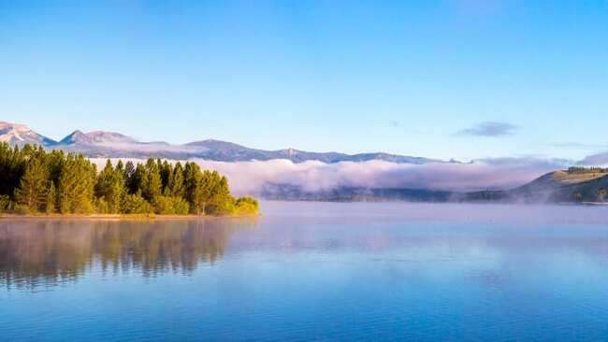

PACKAGE COST & DETAILS
Category | 6-9 PAX (USD) / per person |  |  |  |  | 10-13 PAX (USD) / Per person
 | Double | Triple/CWB | Single | CNB | Quad | Double | Triple/CWB | Single | CNB | Quad
3/4* | 3409 | 3349 | 4399 | 2419 | 3279 | 2859 | 2799 | 3849 | 1869 | 2729

Inclusions:  - Hotel Accommodations  - Breakfast  - Airport Transfers as mentioned  - City Tour: Salt Lake City  - Surface Transfer: Salt Lake City>Jackson Hole>Grand Teton>West Yellowstone-Salt Lake City  - Entrance Tickets: Grand Teton National Park, Yellowstone National Park x02  - All Taxes  - All tours & sight seen on PVT basis | Exclusions:  - International & Domestic Airfare  - Tips to guides & drivers  - Porterage, Laundry bills & other incidental charges  - Anything that is not mentioned in the inclusions part.  - Any Destination Fees/Resort fees at any hotel

HOTELS:
City | Nts. | 3/4* Hotels OR SIMILAR
Salt Lake City | 1 | Hotel Residence Inn / Doubletree /Hilton
Jackson Hole | 2 | Hotel Hampton Inn Jackson Hole / Holiday Inn
West Yellowstone | 3 | Hotel Holiday Inn West Yellowstone / Best Western Desert Inn

BASIC INFORMATION:
Hotels | Transfer | Meal
Check in time: 4pm / Check out time: 11am | PVT basis (Sprinter Van) | Breakfast: As provided by Hotel.
Breakfast time: 6:30 Am to 9:30 Am |  | Lunch: On Own
Incidental Charges and Resort fee. Must be paid by clients |  | Dinner: On own

GENERAL TERMS & CONDITIONS:
- Tours will be conducted in a Van with driver cum guide depending on the number of passengers confirmed.
- Child age 2-9 years. Above 9 years is considered as an adult.
- We reserve the right to use alternative accommodation, sightseeing tours and transfer of equal or higher standards.
- No refunds either in part or full will be made for any unused services in above package like ground transportation, meals, accommodation, sightseeing tours.
- The Incidental charges are not included: for instance: Porterage, tips, laundry, telephone calls, alcohol/non-alcoholic beverages.
- Early check-In is not guaranteed. Every effort will be made for passengers coming in early but this is at the hotel’s discretion & availability.
- Passengers requiring Wheelchair assistance will have to make their own arrangements.
- Please note that some hotels require guests to give their Credit card/cash towards incidentals. No charges are levied unless guests use services not included in the package.
- Please note for dinners in Niagara Falls, Orlando &Las Vegas, and the restaurant will be walking distance from the Hotel and no transfers will be provided for the same.
- Final working itinerary and vouchers will be sent by email 07 days prior to departure date.

