7 DAYS –WESTERN EXPLORER (Van Tour)
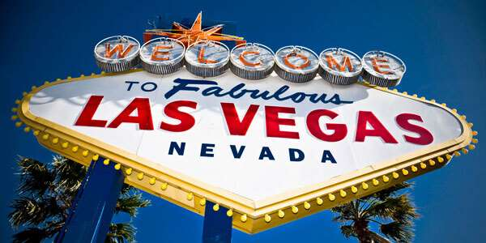

Day 01- Las Vegas City Tour + Stratosphere Tower
Welcome to Las Vegas. Upon arrival, proceed to the hotel for check-in. Later, we proceed for the city tour in Las Vegas, experiencing the spectacular Colorful Dancing Fountain water fountains of the Bellagio, the Pirate Ships at Treasure Island, Downtown Vegas, and of course Fremont street, where over 12 million lights create a free show with pumping music. Later, proceed to visit the Stratosphere Tower. View the city in 360-degree panorama at Las Vegas' Stratosphere Tower, the tallest freestanding observation tower in the United States at 1,149 feet.

Day 02 - Grand Canyon West Rim Bus Tour with Skywalk
Spend the day at the Grand Canyon with our bus tour, including a Hoover Dam Photo stop along the way and the New Wonder of the West, The SKYWALK.

Day 03-Las Vegas - Los Angeles - City Tour
Today, we depart to Los Angeles by road (approx. 4.5 hours).On arrival, proceed for a guided city tour - we will drive you through the “Entertainment capital of the world,” Hollywood, Hollywood Walk of Fame, Beverly Hills, Grumman Chinese Theater, Sunset strip, Rodeo Drive for the world’s most expensive shopping, and Chinatown for some good bargains.

Day 04 - Los Angeles - Universal Studios
Join us today for a tour of Universal Studios, which has always been known for its innovative rides and attractions and is designed to let visitors experience the movies like never before. A trip to Universal is like a trip into the heart of Hollywood. With films and TV shows always in production, one never knows who they might see wandering the sidewalks of the park. (Meals: B)

Day 05- Los Angeles - San Francisco
After breakfast, we depart for San Francisco by road (approx. 8 hours), which is one of the few North American cities to achieve the legendary status of such places as Paris or London. The city's well-known hills offer stunning views of the Pacific Ocean and San Francisco Bay. In addition to its diversity and charm, San Francisco is a gateway to Silicon Valley, America's premier high technology center. Upon arrival, check in to the hotel. (Meals: B)

Day 06- San Francisco City tour + Bay Cruise
Today, we proceed on a sightseeing tour of San Francisco. You will visit the famous Golden Gate Bridge, with the world’s highest bridge towers. Continue on to Twin Peaks, Lombard Street, Cable Car, Pier 39, Nob Hill, Civic Center, Union Square and Fisherman’s Wharf, Palace of Fine Arts, Bay Cruise & other highlights. (Meals: B)

Day 07-Departure from San Francisco
After breakfast, spend some time at leisure. Take some time out for additional shopping, or, proceed to the airport to board the flight for your next destination. (Meals: B)

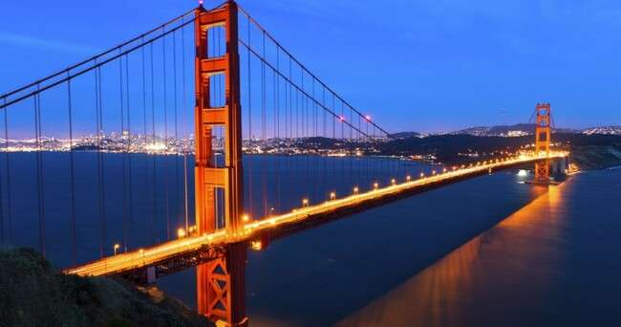
Tour ends with sweet memories.

PACKAGE COST & DETAILS

Category | 6-9 PAX (USD) / per person |  |  |  |  | 10-13 PAX (USD) / per person
 | Double | Triple/CWB | Single | CNB | Quad | Double | Triple/CWB | Single | CNB | Quad
Deluxe | 2529 | 2469 | 3029 | 2039 | 2399 | 2089 | 2029 | 2589 | 1599 | 1959

Inclusions:  - Hotel Accommodations  - Breakfast (Except LAS)  - Airport Transfers as mentioned  - City Tour: San Francisco, Las Vegas, Los Angeles  - Surface Transfer: LAS>LAX> SFO  - Entrance Tickets: Stratosphere Tower, Universal Studio, Bay cruise, Grand Canyon Bus tour with skywalk  - All Taxes  - All transfers & sight seen on PVT (Sprinter Van) | Exclusions:  - International & Domestic Airfare  - Meet & Greet at airport  - Supplement cost applicable for Weekend in LAS  - Breakfast and Resort Fees in LAS.  - Any Destination Fees/Resort fees at any hotel  - Tips to guides & drivers  - Porterage, Laundry bills & other incidental charges  - Anything that is not mentioned in the inclusions part.
Optional cost per person:
- Dinner= USD 35.00 per person

HOTELS:
City | Nts. | Deluxe Hotels OR SIMILAR
LAS | 02 | Hotel Excalibur / Luxor / Strats
LAX | 02 | Hotel Doubletree / Four Point Sheraton LAX
SFO | 02 | Hotel Crown Plaza SFO / Hyatt Place Silicon

BASIC INFORMATION:
Hotels | Transfer | Meal
Check in time: 4pm / Check out time: 11am | All on PVT basis (Sprinter Van) | Breakfast: As provided by Hotel.
Breakfast time: 6:30 Am to 9:30 Am |  | Lunch: On Own
Incidental Charges and Resort fee. Must be paid by clients |  | Dinner: On Own

GENERAL TERMS & CONDITIONS:
- Tours will be conducted in a Van with driver cum guide depending on the number of passengers confirmed.
- Child age 2-9 years. Above 9 years is considered as an adult.
- We reserve the right to use alternative accommodation, sightseeing tours and transfer of equal or higher standards.
- No refunds either in part or full will be made for any unused services in above package like ground transportation, meals, accommodation, sightseeing tours.
- The Incidental charges are not included: for instance: Porterage, tips, laundry, telephone calls, alcohol/non-alcoholic beverages.
- Early check-In is not guaranteed. Every effort will be made for passengers coming in early but this is at the hotel’s discretion & availability.
- Passengers requiring Wheelchair assistance will have to make their own arrangements.
- Please note that some hotels require guests to give their Credit card/cash towards incidentals. No charges are levied unless guests use services not included in the package.
- Please note for dinners in Niagara Falls, Orlando &Las Vegas, and the restaurant will be walking distance from the Hotel and no transfers will be provided for the same.
- Final working itinerary and vouchers will be sent by email 07 days prior to departure date.

