8 DAYS – BEST OF ALASKA
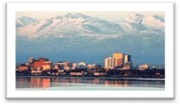

Day 01 - Anchorage
Upon arrival, transfer to your hotel. Within walking distance of most downtown hotels are the Anchorage Museum of History and Art, numerous restaurants, and other downtown attractions.

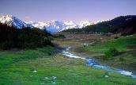
Day 02 – Anchorage City Tour
Visit Anchorage's historical sites on this city sightseeing tour by coach. This 3hour, fully narrated tour is the perfect way to get a comprehensive overview of this great Alaskan city. Enjoy informative live, onboard narration as you visit Earthquake Park and Lake Hood. Then, explore the Alaska Native Heritage Center to get an in-depth look at Alaska’s unique cultural heritage. (Meals: B)

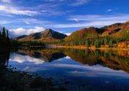
Day 03- Full Day Excursion to Denali National Park (OPTIONAL)
Depart from Anchorage's Merrill Field airport very early in the morning and fly to Denali National Park in a small plane. As you approach and circle Mt. McKinley, watch for climbers on their way to the summit. After landing, you will board a bus for your park tour. Your driver will assist you in spotting wildlife along the road and answer questions about the park and its resources.(Meals: B)

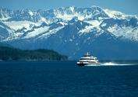
Day 04 - Prince William Sound - 26 Glacier Cruise

Take part on this full-day adventure to Whittier from downtown Anchorage via coach or rail. Take a high-speed catamaran for your cruise through Prince William Sound and watch for sea otters, whales and birds as you travel through glacier-filled College and Harrimann Fjords. This tour provides an excellent opportunity to witness glacier calving.

(Meals: B)

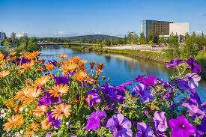
Day 05 – Anchorage - Fairbanks

Today after breakfast proceed by plane to Fairbanks, the largest city in the Interior region of Alaska. Check in & time on own. (Meals: B)

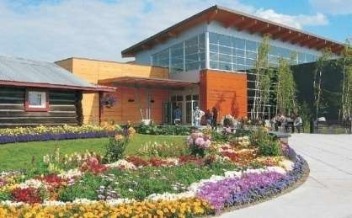
Day 06 –Fairbanks – City Tour

Get to know Fairbanks, called the ‘Golden Heart City,’ on this 5-hour sightseeing tour. Visit the Morris Thompson Cultural and Visitors Center for an intro into the city’s history and culture, and admire the architecture at the University of Alaska’s Museum of the North. Feast your eyes on the Trans-Alaska Pipeline, the world’s largest pipeline, and wrap up your day at the Santa Claus House in the North Pole. (Meals: B)

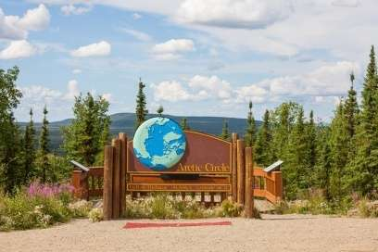
Day 07- Arctic Circle Day Trip
Today we will take you to the Arctic Circle, Earth’s northernmost circle of latitude, where the sky is completely dark or light all day. Aboard a climate-controlled van, cruise along the Dalton Highway, cross the Yukon River and then enjoy lunch in the arctic landscape. Learn about the indigenous Eskimo culture in the region, and take home incredible pictures, as well an official Arctic Circle certificate. (Meals: B)

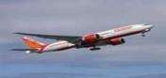
Day 08- Departure
Today we finish our trip and get ready to fly back home or to the next destination. (Meals: B)

PACKAGE COST &DETAILS
Category | 2 - 5 PAX (USD)
 | Double | Triple/CWB | Single | Child No bed | Quad
Moderate | 2259.00 | 2179.00 | 3189.00 | 1319.00 | 2099.00
Deluxe | 2809.00 | 2729.00 | 4149.00 | 1489.00 | 2649.00

Inclusions:  - Hotel Accommodations  - Breakfast  - Airport- Hotel-Airport Transfers  - City Tour on SIC: Anchorage, Fairbanks  - Arctic Circle Day Trip  - Visit Prince William Sound- 26 Glacier Cruise All tours & transfers on SIC  - All Taxes | Exclusions& Important notes:  - International & Domestic Airfare  - Meet & Greet at airport  - Any Destination Fees/Resort fees at any hotel  - Tips to guides & drivers  - Porterage, Laundry bills & other incidental charges  - For SIC tours – Hotel pick & drop not guaranteed. Client will have to arrange the transfer on its own for any SIC tours.  - Anything not mentioned in inclusions section
Optional cost per person:
- Mt Denali Flightseeing Tour from Anchorage with Glacier Landing = USD 649.00 per person
- Glaciers and Wildlife: Super Scenic Day Tour from Anchorage = USD 225.00 per person

HOTELS WILL BE AS BELOW OR SIMILAR:
City | Nts. | Moderate Hotels | Deluxe Hotels
ANC | 04 | Hotel Clarion Suites / Holiday Inn Express | Hotel Crown Plaza / Springhill Suites Marriott
Fairbanks | 03 | Hotel Best Western / La Quinta | Hotel Holiday Inn / Hampton Inn / Candlewood Suites

BASIC INFORMATION:
Hotels | Transfer/Sightseeing’s | Meal
Check in: 4pm / Check out: 11am | 2-5 Pax – SIC basis | Breakfast: As provided by Hotel.
Breakfast time: 6:30 Am to 9:30 Am
Incidental Charges Must be paid by clients

TERMS & CONDITIONS:
- All rates are based on minimum 2Pax traveling together at all tours.
- Surcharges apply for any trade fair/special event/weekend in LAS or any other event in city.
- Child age 2-9 years. Above 9 years is considered as an adult.
- All rates and availability are subject to change at the time of booking.
- Some events are seasonal like Maid of the Mist, Cave of the Winds, Beast ride, Yosemite Park, Lake Tahoe etc. (Will be closed for winter)
- Optional Meals do not include transfers; the meal will be delivered to your hotel if the restaurant is not within walking distance.
- SIC Tour / Transfer pick-up depends on hotel location, if hotel is outside of pick-up zone, clients will have to make own arrangements.
- We reserve the right to use alternative accommodation, sightseeing tours and transfer of equal or higher standard.
- No refunds either in part or full will be made for any unused services in above package like ground transportation, meals, accommodation, sightseeing tours.
- We are not responsible for any missed breakfast due to flight timings.
- No Intercity surface transfers are included unless specified in the package.
- We are not responsible for any baggage charges by any airlines for the clients.

- Payment for the tour must be made as per the invoice, payment terms & conditions.

