08 DAYS – BEST OF MEXICO

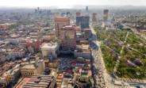
Day 01 - Mexico City
Welcome to the glory of Old Mexico. See the ancient cultures of the Nahua, Aztec, Olmec, Toltec, and Mayan civilizations. Arrive in Mexico City, the capital of this fascinating country, with exotic indigenous and international cultures, close yet breathtakingly foreign. Check into hotel upon arrival.

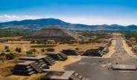
Day 02 -Mexico City - Teotihuacan

Experience the ancient City of the Gods on a visit to the archaeological site of Teotihuacan. Your full day guided tour will highlight the complexities of Aztec treasures. You'll have the opportunity to climb the Pyramids of the Sun and Moon and see the Butterflies Temple, the Avenue of the Dead and the Temple of Quetzalcoatl. (Meals: B)

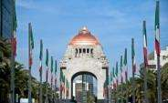
Day 03 - Mexico City- City Tour

After breakfast, immerse yourself in Mexico City on a city tour. Whether you're passionate about history and art, or just yearning for adventure, you'll travel by coach to some of Mexico City's major attractions including the Chapultepec area, the Anthropology Museum, Metropolitan Cathedral and the National Palace. (Meals: B)

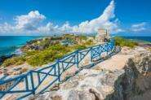
Day 04 - Mexico City - Cancun
After breakfast, depart to Cancun. The city of Cancun is young, as are most of its permanent and temporary inhabitants. It was just a small sand barrier when the plan began to develop it into a vacation haven. Cancun consists of a medium-sized coastal city and a long, thin island connected to the mainland through bridges at its north and south ends. Check-into the hotel upon arrival.(Meals: B)

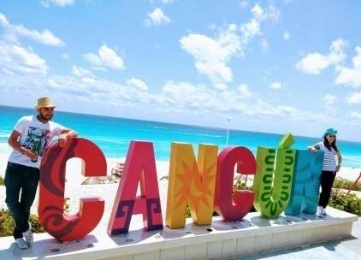
Day 05 - Cancun City Tour & Shopping
Pair Mayan-ruins sightseeing with shopping on this combo tour. Discover the archaeological site of El Meco, and learn about its historical role in trade. Move on to an artisanal craft market, Celso at Market 28, in the heart of Cancun. Visit Cancun landmarks and highlights, including the Tequila Museum. Snap frame-worthy photos of Cancun’s coastline at El Mirador in Playa Delfines. (Meals: B)

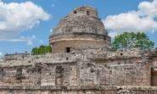
Day 06 - Cancun -Chichen Itza
Spectacular Chichen Itza holds both mystery and magic. Explore the most important archaeological zone and ancient capital of the Mayan Empire on a full day guided tour from Cancun. Admire the majestic observatory, the sacred cenote, the ball court and the castle. (Meals: B)

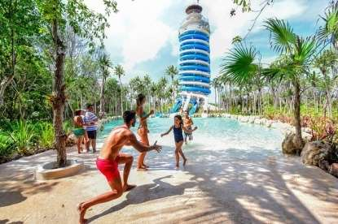
Day 07 - Cancun – Xel-Ha All-Inclusive
Explore Xel-Ha Park, the Riviera Maya's stunning natural aquarium, on this all-day trip from Cancun. Relax on Xel Ha's hidden beach, swim in cenotes and lagoons, go snorkeling, and spelunk in caves. Watch out for wildlife like angelfish and iguanas. Xel-Ha is all-inclusive, so enjoy Mayan cuisine, seafood and burgers with your admission. (Meals: B)

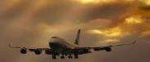

Day 08- Departure from Cancun
Today we finish our trip and get ready to fly back home or to the next destination. (Meals: B)

PACKAGE COST & DETAILS
Category | 2 – 5 PAX (USD)
 | Double | Triple/CWB | Single | Child No bed | Quad
Moderate | 1819 | 1739 | 2399 | 1249 | 1659
Deluxe | 2199 | 2129 | 3169 | 1299 | 2049

Inclusions:  - Hotel Accommodations  - Breakfast  - Airport- Hotel-Airport Transfers  - City Tour on SIC: Mexico City  - Entrance Tickets with transfers:  - Xel-Ha All-Inclusive  - Chichen Itza  - Teotihuacan  - Cancun Shopping and City Tour  - All tours & transfers on SIC  - All Taxes | Exclusions:  - International & Domestic Airfare  - Meet & Greet at airport  - Any Destination Fees/Resort fees at any hotel  - Tips to guides & drivers  - Porterage, Laundry bills & other incidental charges  - For SIC tours – Hotel pick & drop not guaranteed. Client will have to arrange the transfer on its own for any SIC tours.  - Anything not mentioned in inclusions section

HOTELS WILL BE AS BELOW OR SIMILAR:
City | Nts. | Moderate Hotels | Deluxe Hotels
MEX | 03 | Hotel Ramada /Holiday Inn /Ibis | Hotel Hilton / Residence Inn / Doubletree
CAN | 04 | Hotel Aloft / Holiday Inn | Hotel Marriott / Sheraton

BASIC INFORMATION:
Hotels | Transfer/Sightseeing’s | Meal
Check in: 4pm / Check out: 11am | 2-5 Pax – SIC basis | Breakfast: As provided by Hotel.
Breakfast time: 6:30 Am to 9:30 Am
Incidental Charges Must be paid by clients

TERMS & CONDITIONS:
- All rates are based on minimum 2Pax traveling together at all tours.
- Surcharges apply for any trade fair/special event/weekend in LAS or any other event in city.
- Child age à 2-9 years. Above 9 years is considered as an adult.
- All rates and availability are subject to change at the time of booking.
- Some events are seasonal like Maid of the Mist, Cave of the Winds, Beast ride, Yosemite Park, Lake Tahoe etc. (Will be closed for winter)
- Optional Meals do not include transfers; the meal will be delivered to your hotel if the restaurant is not within walking distance.
- SIC Tour / Transfer pick-up depends on hotel location, if hotel is outside of pick-up zone, clients will have to make own arrangements.
- We reserve the right to use alternative accommodation, sightseeing tours and transfer of equal or higher standard.
- No refunds either in part or full will be made for any unused services in above package like ground transportation, meals, accommodation, sightseeing tours.
- We are not responsible for any missed breakfast due to flight timings.
- No Intercity surface transfers are included unless specified in the package.
- We are not responsible for any baggage charges by any airlines for the clients.
- Payment for the tour must be made as per the invoice, payment terms & conditions.

