8 DAYS – BEST OF WEST CANADA

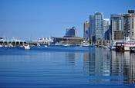
Day 01- Arrive inVancouver
Today you will fly to Vancouver, which is truly one of the world's most beautiful cities and one of the healthiest places to visit or live. It is a sophisticated, vibrant, fun loving, outdoor living city. Upon arrival, check in hotel and spend time at leisure.

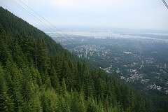
Day 02 – Vancouver City Tour- Grouse Mountain - Suspension Bridge
This all day tour combines Vancouver Highlights with the best of the North Shore: Capilano Suspension Bridge and Park, and Grouse Mountain, including the Grouse Mountain Sky ride to the top of the mountain. You’ll see Stanley Park, Chinatown, Gas town, English Bay and Yaletown downtown. You’ll also have plenty of time to explore Capilano Suspension Bridge, with its Tree Top Adventure, Cliff Walk and the amazing bridge itself. Then it’s up to the top of Grouse Mountain by gondola, where you’ll have time to visit Coola and Grinder, the two orphaned Grizzly Bears,watch amazing lumberjacks and the Lumber Jack Show, Birds in Motion, and the Theatre in the Sky. (Meals: B)

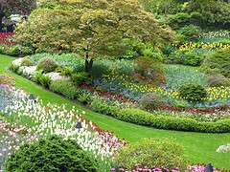
Day 03 -Victoria & Butchart Garden Tour
Today you will enjoy a 90 minute cruise through the spectacular Gulf Islands. Watch for whales, sea lions and bald eagles. You will visit Butchart Gardens, which is fifty-five acres of flowers, trees, pathways and creeks. Featuring a sunken garden, a world famous rose garden and a wonderful restaurant serving High Tea daily, Butchart Gardens is one of the most beautiful and best maintained gardens in the world. Tour the city of Victoria and take a scenic drive along the coast and enjoy the views. Ride through the famous Oak Bay and Uplands residential areas, plus the University of Victoria, Beacon Hill Park, Chinatown, and Downtown. (Meals: B)

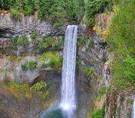
Day 04 - Vancouver- Whistler & Shannon Falls Tours
After breakfast, you will enjoy the breathtaking views and scenic stops along the thrilling Sea-To-Sky Highway. Feel the mist of the spectacular 335-meter Shannon Falls. In Whistler, you will have time to dine, shop, take the Peak 2 Peak gondola, bike or stroll along the trails. Seasonally, ride the Gondola to the Peak of Whistler Mountain. Enjoy glacier, mountain and river views on your leisurely ride home. (Meals: B)

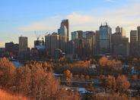
Day 05 - Calgary
Today we proceed by plane/train to Calgary; the largest city in the province of Alberta, Canada. It is located in the south of the province, in a region of foothills and high plains, approximately 80 km east of the front ranges of the Canadian Rockies. Upon arrival, check-in to the hotel. Spend rest of the day at leisure. (Meals: B)

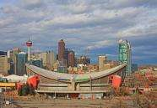
Day 06-Calgary City Tour
After breakfast, you will proceed for a city tour of Calgary and visit Calgary Tower, Old and New City Hall, Olympic Plaza, Fort Calgary Historic Park, Chinatown, Eau Claire Market Mall, Stephen Avenue, Devonian Garden, Stampede Park, Saddle dome and much more. (Meals: B)

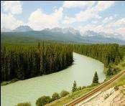
Day 07 - Banff City Tour &Gondola Ride
Today, you will enjoy a stunning tour, which is a great way to see Banff and its surrounding areas from an amazing selection of perspectives. A full day excursion takes you from the city of Calgary into the Canadian Rockies through Alberta's foothills and ranching country to the resort town of Banff in the Rocky Mountains. Experience our stories of the people, geology, and the building of this mountain town. This day trip includes admission to the Banff Gondola, where an 8-minute gondola car takes you to the top of the mountain. (Meals: B)

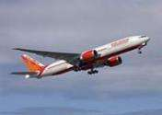
Day 08- Calgary - Fly Out
Today, we finish our trip and get ready to fly back home or to the next
destination.(Meals: B)

PACKAGE COST & DETAILS
Category | 2 - 5 PAX (USD)
 | Double | Triple/CWB | Single | Child No Bed | Quad
Moderate | 2419 | 2349 | 2969 | 1849 | 2269
Deluxe | 2859 | 2789 | 3829 | 1929 | 2709

Inclusions:  - Hotel Accommodations  - Breakfast  - Airport- Hotel-Airport Transfers  - City Tour on SIC: Calgary, Vancouver  - Day trip to Banff with Gondola Ride  - Day trip to Grouse Mountain & Capilano Suspension Bridge  - Day tour to Victoria & Butchart Garden  - Day tour to Whistler with Shannon Falls  - All tours & transfers on SIC  - All Taxes | Exclusions & Important notes:  - International & Domestic Airfare  - Intercity travel by Flight / Bus / Train  - Meet & Greet at airport  - Any Destination Fees/Resort fees at any hotel  - Tips to guides & drivers  - Porterage, Laundry bills & other incidental charges  - For SIC tours – Hotel pick & drop not guaranteed. Client will have to arrange the transfer on its own for any SIC tours.  - Anything not mentioned in inclusions section
Optional cost per person:
- 2-5pax= Return PVT Airport trns Per Dest=
USD 35 per person

HOTELS WILL BE AS BELOW OR SIMILAR:
City | Nts. | Moderate Hotels | Deluxe Hotels
VANC | 04 | Fairfield Inn / Holiday Inn Express or similar | Four Point Sheraton / Radisson or similar
CAL | 03 | Holiday Inn Express / Ramada or similar | Radisson / Hyatt Place or similar

BASIC INFORMATION:
Hotels | Transfer/Sightseeing’s | Meal
Check in: 4pm / Check out: 11am | 2-5Pax – SIC basis | Breakfast: As provided by Hotel.
Breakfast time: 6:30 Am to 9:30 Am
Incidental Charges Must be paid by clients

TERMS & CONDITIONS:
- All rates are based on minimum 2Pax traveling together at all tours.
- Surcharges apply for any trade fair/special event/weekend in LAS or any other event in city.
- Child age 2-9 years. Above 9 years is considered as an adult.
- All rates and availability are subject to change at the time of booking.
- Some events are seasonal like Maid of the Mist, Cave of the Winds, Beast ride, Yosemite Park, Lake Tahoe etc. (Will be closed for winter)
- Optional Meals do not include transfers; the meal will be delivered to your hotel if the restaurant is not within walking distance.
- SIC Tour / Transfer pick-up depends on hotel location, if hotel is outside of pick-up zone, clients will have to make own arrangements.
- We reserve the right to use alternative accommodation, sightseeing tours and transfer of equal or higher standard.
- No refunds either in part or full will be made for any unused services in above package like ground transportation, meals, accommodation, sightseeing tours.
- We are not responsible for any missed breakfast due to flight timings.
- No Intercity surface transfers are included unless specified in the package.
- We are not responsible for any baggage charges by any airlines for the clients.
- Payment for the tour must be made as per the invoice, payment terms & conditions.

