8DAYS- EASTERN USA (UNIVERSITY TOUR)

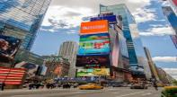
Day 01- Arrive in New York
Welcome to the "Big Apple," the "City That Never Sleeps"—New York is a city of superlatives: America's biggest; its most exciting; its business and cultural capitals; the nation's trendsetter. For more than a century, it has been one of the world's major centers of commerce and finance. Upon arrival at the airport, you will be transferred to the hotel. (Meals: D)

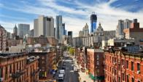
Day 02 – New York City Tour
After breakfast proceed for a City tour of New York. The sight seen will include USA’s famous landmark “Statue of Liberty”. We will take a ferry ride to Liberty Island for a spectacular view of the New York City Skyline. Next we experience the view of a lifetime from the 86th floor of the Empire State Building, Later in the day we will see Rockefeller Center, Wall Street, Ground Zero and Central Park, Times Square, United Nations, Trump. (Meals: B, L, D)

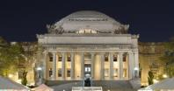
Day 03- New York –Boston

Breakfast at the hotel, and then tour the campus of Columbia University in New York. Columbia University was founded in 1754 as King's College by royal charter of King George II of England. It is the oldest institution of higher learning in the state of New York and the fifth oldest in the United States. Afterwards proceed to Boston. Check into hotel upon arrival.(Meals: B, L, D)

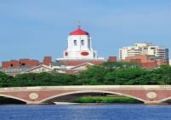
Day 04- Boston City Tour
Enjoy Breakfast at the hotel. Start your day at Harvard with a tour of Harvard led by a Harvard Student. Travel on to MIT to tour the great MIT campus with an MIT student. Afterwards explore the MIT Museum. Proceed to visit prominent sites in Boston such as the State House, on Beacon Hill overlooking the Boston Common. You can view Boston's skyline and Charles River from the Harbor. Then continue to visit City hall, Boston Common, New Bury Street (Copley Square), Freedom Trail and Quincy Market, also known as Faneuil Hall Marketplace. (Meals: B, L, D)

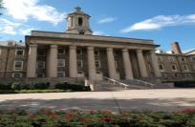
Day 05 – Boston –Philadelphia

Breakfast at the hotel and then proceed to Philadelphia, upon arrival tour the campus of the University of Pennsylvania. Afterwards enjoy a city tour, see the Delaware River, Elfreth’s Alley, Christ Church, the Liberty Bell and Independence Hall, and many other parts of the Historic District. You’ll take in the waterfront and the Irish Memorial, City Hall, drive down the Avenue of the Arts and Benjamin Franklin Parkway, and see the Philadelphia Museum of Art, home to Rocky’s statue and the famous steps! Check into your hotel. (Meals: B, L, D)

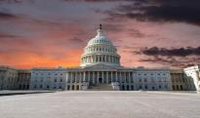
Day 06 – Philadelphia - Washington
Today we proceed by coach to Washington DC, capital of the United States of America and a Guide to the Historic Neighborhoods and Monuments. The city attracts almost twenty million visitors each year. Upon arrival tour the campus of the George Washington University. (Meals: B, L, D)

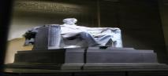
Day 07 - Washington City Tour
After Breakfast, you will explore the capital city of US. Visit the White House, Lincoln Memorial, Supreme Court, the Capitol Building, the Smithsonian Air and Space museum, Union Station, World War II Memorial Building, Pentagon building and Washington monument. (Meals: B, L, D)

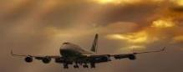
DAY 08 – Departure from Washington
Today we finish our trip and get ready to fly back home or to the next Destination. (Meals: B, L)

MIN. 25 PAX | Double | Triple | Single | Quad
Moderate | 1549 | 1479 | 1969 | 1399
Inclusions:  - Hotel Accommodations  - Breakfast, 7 Lunches & 7 Dinner  - Airport- Hotel-Airport Transfers  - Intercity Surface Transfers: NYC>BOS>PHL>WAS  - City Tour: New York, Boston, Philadelphia, Washington D.C  - Entrance Tickets with transfers: Statue of Liberty, Empire State Building  - Campus tours: Columbia University, Harvard, MIT, University of Pennsylvania, George Washington University  - All Taxes  - 01 FOC for Tour Leader | Exclusions:  - International Airfare  - VUSA Air Tickets & baggage charges & Porterage
City | Nts. | Moderate Hotels or similar
NYC | 02 | Hotel Holiday Inn NJ / Laquinta Inn NJ / Fairfield Marriott NJ
BOS | 02 | Hotel Holiday Inn Express / Best Western
PHL | 01 | Hotel Comfort Inn / Holiday Inn Express /Best Western
WAS | 02 | Hotel Wingate Dulles / Comfort Inn

BASIC INFORMATION:
Hotels | Transfer | Meal
Check in time: 4pm / Check out time: 11am | All on PVT basis | Breakfast: As provided by Hotel.
Breakfast time: 6:30 Am to 9:30 Am |  | Lunch: Indian / International / Packed Lunch
Incidental Charges Must be paid by clients |  | Dinner: Indian (as per the group request)

TERMS & CONDITIONS:
- The above cost is based on minimum 25pax travelling together. Surcharges may apply for less no. of pax.
- The tour will be operated subject to min. 25paying passengers. In the event that group size is less, you will be given an option of travelling another departure date.
- Booking Deposit Fees: USD 500.00 per person
- Cancellation Policy- 30days & above- Full refund
29-15 days- 50% Refund
14-0 days- 0% Refund
- Surcharges apply for any trade fair/special event/weekend in LAS or any other event in city.
- Campus Tours are not available on weekends or holidays.
- All rates and availability are subject to change at the time of booking.
- Some events are seasonal like Maid of the Mist, Cave of the Winds, Beast ride, Yosemite Park, Lake Tahoe etc. (Will be closed for winter)
- We reserve the right to use alternative accommodation, sightseeing tours and transfer of equal or higher standard.
- No refunds either in part or full will be made for any unused services in above package like ground transportation, meals, accommodation, sightseeing tours.
- We are not responsible for any missed breakfast due to flight timings.
- No Intercity surface transfers are included unless specified in the package.
- We are not responsible for any baggage charges by any airlines for the clients.
- Payment for the tour must be made as per the invoice, payment terms & conditions.
- Campus tours are not offered on weekends, during University holidays or Student breaks.

